**Chapter 77 – Grandchildren 2013 – present (2019 now)**

**JANAE:**

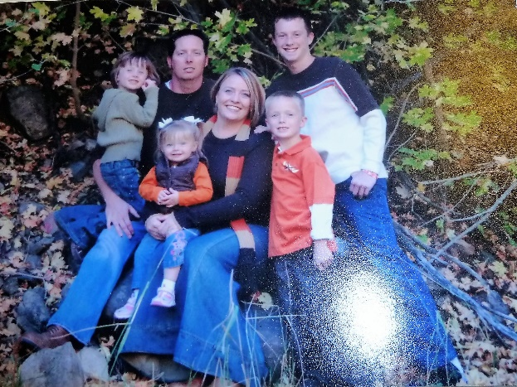**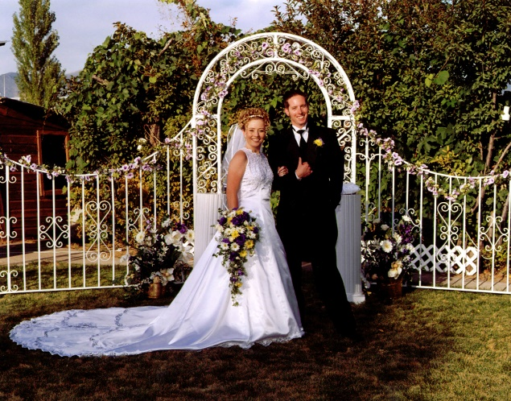JaNae is our oldest grandchild.** She has a beautiful smile and is a beautiful woman. **JaNae** married a wonderful man, **Brad Caires.** Brad wasn’t a member, but later joined the church and they became active. They have three special children – **Dawson, Kennedy and Emma**.

Brad was on high pain pills because of terrible pain from his operation that resulted from a fight with a burglar who was in their garage stealing expensive equipment and tools that Brad had there. He also had arthritis from hurting himself while as a youth riding motorcycles. Brad had had a good job at Tooele Army Depot disarming explosives, so they bought a beautiful home in Stockton, a nice truck and other toys and furniture. Brad quit this job to go into business for himself, making special tools for mechanics. He was doing pretty well, until this happened and he couldn’t work anymore. Brad is a good man and a good husband and father, and it is sad to see how his health has gone since all this has happened. They ended up losing their home and practically everything they had. It was a hard time for them. Bishops helped them with church welfare and got them into a trailer home in Grantsville.

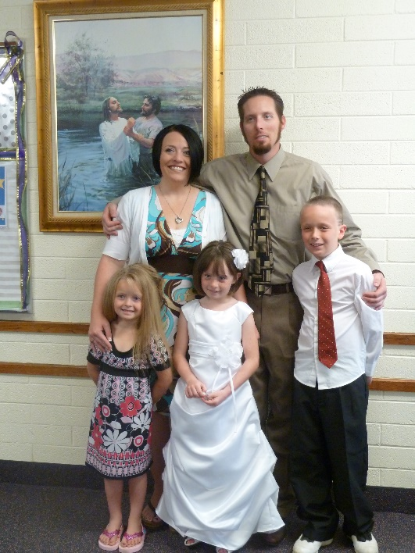 Before Brad & JaNae lost their home, JaNae and Sandi had a terrible fight. I won’t devolve what it was about, but it was heart breaking and there were angry feelings on both sides for about 3 or more years. I felt Sandi was doing what she felt she needed to do, but JaNae didn’t take it well. Because of the situation, JaNae told Sandi that she was a terrible mother and that she was not allowed to see these grandchildren again. You can imagine what that did to Sandi, especially when she has been such a wonderful mother to her daughters, and a wonderful grandmother. She even had a cute playroom build in her basement with a playhouse, slippery slide, etc. She is so artistic that she decorated the walls. Any child would love that playroom. Sandi has done so much for and with her daughters and their families. It has been especially hard on Sandi as she loves this daughter and those grandchildren so much. JaNae’s children loved their grandmother, so it was so hard on them also. Sandi was visiting Shellie and her family in Arizona at the time JaNae called, and that surely spoiled her vacation. We are heartsick about it too.

I love JaNae very much and want to help her and her family if I can, but her mom is my daughter and I love her so very much too. I don’t like being in the middle and I don’t want to take sides, so I will just love them both and do the best I can, and hope and pray that someday they will forgive each other and love and care for each other again.

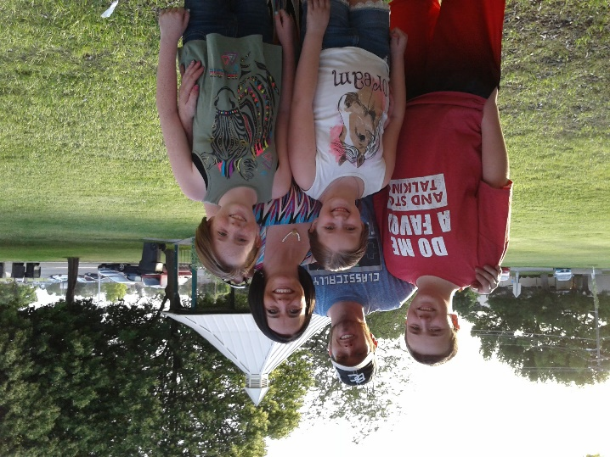I had kept in touch with JaNae, and had called and talked to her several times and had invited them to come here for dinner and one-time Ken and I took dinner out to them in Grantsville and we all had a picnic in the park, and had a good time.

It is now 2018, and at our last Thanksgiving dinner at our stake center here in Roy (2017), JaNae, Brad and the children came. After that terrible time, JaNae wouldn’t come to any family parties or activities as she knew her mom would be there and she wouldn’t come if her mom was coming. Wow! This was hard on all of us, but this time they came and we were all so happy to see them again. Sandi had softened and had wanted a relationship with JaNae & her family. Here at this time, Sandi and Gary, JaNae & Brad, Chelci & Steve and I think some of the older children all played games together after our dinner and they laughed and had so much fun together. This made me so happy.

This year, JaNae called and said the missionaries were teaching Emma, as Emma hadn’t been baptized and was ten years old, and asked if we could come to Emma’s baptism and if Ken (Emma’s great grandpa) could baptize and confirm her. Of course, we were thrilled.

JaNae called her sister, Chelci, and asked if their family could come also. I loved hearing what Steve said when Chelci asked him about going. Steve’s family always has their family party every year, on the Saturday that Emma was to be baptized. Sandi told me that when Chelci told Steve about it and asked him what they should do, that he said “My family has this party every year, and Emma’s baptism is a once in a lifetime event, so we need to go support her and her family.” I was so proud of Steve and thankful he felt this way. I think Chelci asked JaNae if her mom could come also, and she said “yes”, so we all came and it was great to be all together again. The baptism was special. JaNae had asked if I would give one of the talks, so I gave the baptism one and one of the Elder’s who taught Emma gave the talk on the Holy Ghost. Sandi played the piano and Chelci lead the music. Ken baptized and also confirmed Emma and gave her the gift of the Holy Ghost. We all went out to eat before the baptism and it was fun being together. As we were all leaving, after the baptism, we gave hugs as we said our “goodbyes” and I saw Sandi and JaNae hugging and they told each other that they loved her. That surely made me happy as I have always wanted them to be close again and love each other.

JaNae, Brad and their family came to our Family Christmas party and Brad looked so good, we hadn’t seen him look that good for years. JaNae said that when they went to California to be with Brad’s aunt and uncle for Thanksgiving, Brad got worse and when they got home, he went to the hospital. They found Brad had staph infection. They had to operate and it left a big hole in his leg, but after he recovered, he began to heal and now he has gained weight and looks and feels so much better. I guess he had had the staff infection for some time, no wonder he wasn’t doing good.

**April 2019,** I just called JaNae as I hadn’t talked to her or seen her for quite a while. She sounded good and said they are all doing fine. She is doing indexing on Family Search and enjoying it. She is also uploading pictures of her and Brad’s relatives and ancestors. I was excited to hear that. She also said that her mom and Gary had come up and Sandi had taken her grandchildren shopping for their birthdays. All three children were born in March. JaNae said that they all went out to eat after Sandi and the children came back from shopping and they had a good time. I was glad to hear that also. It is so good to have those broken relationships healed and them loving and enjoying each other again.

**June 11,2019,** Ken and I went to Chubbuck, Idaho to Terry & Angela’s home where they hosted our sibling and spouse get together. We stayed overnight and left the next morning, after breakfast, to go to Idaho Falls to visit JaNae, Brad and their children. They have just bought a home. With Brad’s health being so good now, he is able to work some. He is working with a man who flips homes. Brad was able to find one of them for a good price, and it was one they could move right into. It is just a block and a half from where they lived before, so the children go to the same schools and they thought they would be in the same ward, but found out after, that the boundary line is their road which means they are in a different ward and it is an older ward with not many children or youth. This is sad as Kennedy had several friends in the other ward and their teacher took them to the temple to do baptisms for the dead frequently and Kennedy loved doing that. Emma had good friends there also. I don’t think Dawson is very active, but is such a sweet and good kid. We had a great time. We got there about noon.

JaNae took me on a tour of the home and yard. It is a nice older home. It has three levels, like many homes and the kids all have their own rooms. They have doors going out onto a deck. I love their yard, both front and back, as they are large with big shade trees. It is pretty private in the back and I thought I would enjoy sitting in a lawn chair under one of their trees reading a good book, if I lived there. We are happy for them. Brad has a friend, whose father passed away and the mother had already passed away, so they had an estate sale. The friend had put stickers on all the furniture he and his wife wanted and he asked Brad if he would come and help him move it all into a large trailer he has. Brad, of course, did and they worked from 9 am until 8 pm. The friend said “Let’s stop at your home for a minute”, so they did, but the friend backed the trailer into Brad’s driveway and then unhitched the trailer. Brad asked him what he was doing, and the friend said: “We don’t need this furniture, but you do so we are giving it all to you. When you finish unloading it, you can bring my trailer back”. He knew that Dawson could help him unload it. Wow! What a blessing for them. There were beds, dressers, a hideaway couch, nice end tables and coffee table, curio cabinet, entertainment center, beautiful recliners and rocking chairs, tools, patio furniture, camp chairs, etc., etc. They are set now. They even asked us if we needed any furniture, but we don’t.

Brad grilled chicken breasts for us and JaNae & Kennedy made a nice green salad and heated pork & beans. They even had ice cream and sherbet for dessert. Ken, of course, couldn’t have that, but I had a little sherbet. Kennedy cleaned up the table and did the dishes. I thought that was special of her. We played a fun game and then we had to leave. We were really glad we came and we love that special family.

**Chelci:**

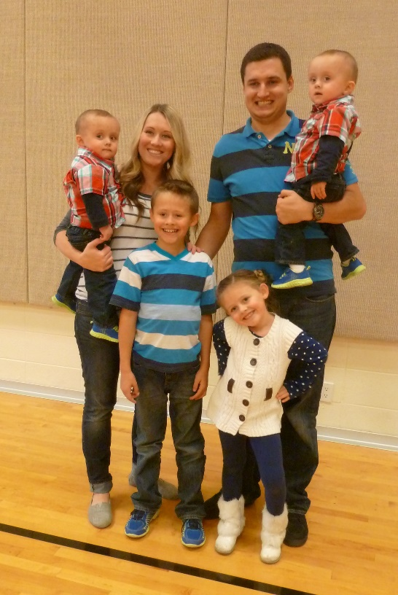**Chelci** is a beautiful and special woman, and is our second grandchild. Chelci was good at clogging also, but her best talent is her beautiful voice. She has shared this talent at government meetings, sports events, church meetings and activities.

Chelci was the Queen of Grantsville and also the High School Homecoming Queen, when she was a senior, and she was also a cheerleader in High School. Chelci married **Steve Holste** in the Salt Lake temple. We were there with them and it was a beautiful ceremony. Of course, Sandi and Terry were there also and Steve’s parents and brothers and sisters-in-law. We all went out to lunch afterwards. They had a beautiful reception. Four special children were born to them – Nathan, Addison “Addie” Mae, Jacob & Luke.

Chelci went to college and became a dental hygienist. She is very good at it, but only works one day a week now, since she has a busy family. After the twins were born, Luke and Jacob, Sandi took care of them while Chelci worked, and helped her with them whenever she could. They are so cute, but so are Nathan and Addie

Chelci and Stephen are good parents. Stephen is in the computer industry and makes good money, so they have a beautiful home in Grantsville. Chelci is a wonderful housekeeper and homemaker, like her mom. Chelci & Steve both have strong testimonies of the gospel and are active in the church, and are teaching their four children the principles of the gospel and setting good example for them.

With Chelci’s beautiful voice, she sings at the County Fair and other community & ward meetings or activities. Ken & I love to go out and watch her sing whenever we know about it and can go. Chelci is in a band named **“Exit 88”** and is the lead singer and plays a guitar. They practice every Friday night. They play for many groups, city and county events.

Three years ago, it was Chelci and Steve’s 10th anniversary and they wanted to go on a cruise. They hadn’t been able to go on a vacation together since they were married. Sandi would be to a school conference in St. George, so wouldn’t be able to tend the children and neither could Steve’s mom, so she called and asked her grandpa and I if we possibly could come to their home and be with the children. We had planned to go to Shellie & Roy’s the following week, so we agreed. They wouldn’t get home until Friday night (if I remember correctly), so she said Steve’s mom could come that morning and we could leave. We went out on the Sunday night and Chelci & Steve left the next morning. I was nervous since the twins didn’t know us very well, and so they might not be happy with us and would miss their parents. Chelci had given us the children’s schedule on Sunday night and told us all the information we needed to know. Chelci got the twins in their highchairs and got them a snack, and then they snuck out. The twins seemed a little upset when they realized their parents were gone, but from then on, they were great! We would say: “Do you want to go outside and play?”, and they would run to their coat hooks, grab their jackets and were ready to go. Also, we would take them on walks and they loved that. Nathan was in school and Addie was in pre-school, so Ken and I would get up early to get breakfast for them and help them get ready for school. Chelci’s friend would stop and pick up Addie and bring her home afterwards. Sometimes she asked if Addie could go and play with her daughter, who was the same age. Nathan had piano lessons, so we took him there. We played games with them, fixed meals and had a great time with these special children. The twins played with each other in their upstairs play room. Once in a while, I would hear them fight, but by the time I got up there, they were fine. They were so good to go to bed at night and wake up happy the next morning. They were good to let me change their diapers and get them dressed. They had binkes, but they were only supposed to have them when they took their naps or went to bed at night. They surely knew which one was theirs.

The only problem we had was that Nathan had the flu, so he wasn’t feeling the best, and I got it from him, so didn’t feel the best either. The twins had diarrhea, so Ken got that. He asked me to pick up some Pepto Bismo at the drug store for him after I picked up Nathan from his piano lesson. He started taking it, but didn’t know if he should still take his acid reflux pills, so he didn’t. Well, that caused more problems and on Wednesday or Thursday, he started having bad hiccups, belching and having pain in his chest and stomach. When Steve’s mom came on Friday morning, we left planning to still go to Shellie’s. Everyone felt much better except Ken, but he thought he would be okay. We got as far as Judy Giles in Kanab, where we were spending the night and he didn’t sleep (neither did I) as he was miserable with the acid reflux. We had to turn around and come home. (Ken and I have written about that in our journals, so I won’t go into it now)

Chelci and Steve were on a cruise, but they didn’t enjoy it as much because Steve got the flu, from his kids, and was sick most of the time, darn it. We love this special family.

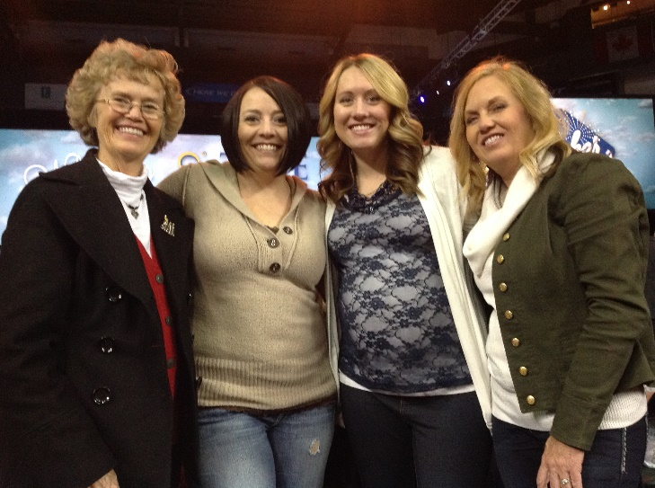**Sandi’s daughters: JaNae & Chelci**

Sandi invited me, and her daughters, JaNae & Chelci, to this special “Time out for Women” conference in Salt Lake. She paid for our tickets and drove us there. That was so special of her. We all had a great time.

.

**GARRETT SEYMORE**

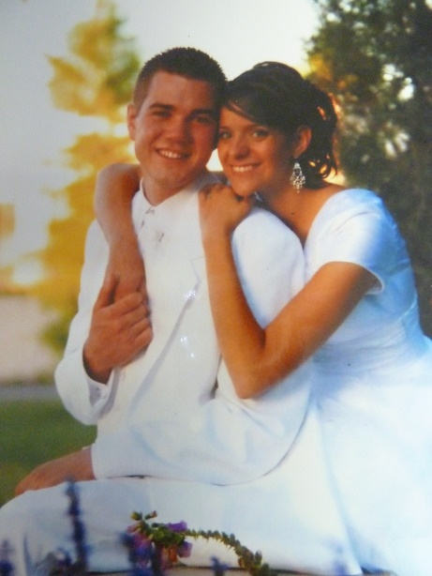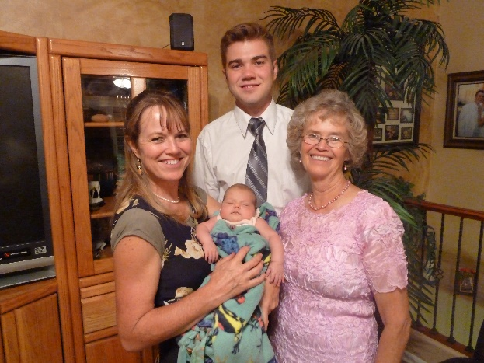**Garrett** is our oldest grandson. He has always been a wonderful son and grandson. He s very smart and very dedicated. He got high grades in school, got a 4-year scholarship to Arizona State University (ASU). He fulfilled an honorable mission to the state of Washington, came home and met a wonderful and beautiful young woman, Nora, and they were married in the Mesa Temple. Sandi, JaNae, Chelci, and Ken and I were able to come down for their wedding. It was a beautiful welling and reception. Shellie always wanted a daughter and now she has one, and she loves Nora very much, and this love is returned. Garrett and Nora both graduated from ASU and Garrett decided he wanted to become a dentist. He knew he couldn’t afford to paid for that schooling, so he enlisted in the Army and got his dental schooling through the military. It was very hard, but he put in the hours needed to study, (even though he didn’t get the sleep he needed and didn’t take time to eat sometimes, even though Nora fixed good food and encouraged him to eat.) They had a darling little daughter, Maggie Lorraine, which made them so happy and made Shellie and Roy grandparents, and they are so thrilled to have a little granddaughter. Two years later they had a cute little son, Damon.

The time came when Garrett had completed his schooling and just needed his internships, his big thesis and the final tests to get his license and become a certified dentist. He called Ken and I one day and asked if he could come and stay with us for the four weeks that he would be doing an internship in Salt Lake City. We were thrilled. We asked if his family could come also, and he said that they could come for the first week, but then would have to return as they had other commitments there in Mesa. We enjoyed being with this cute family. Nora was so sweet and fun to be with, and Maggie & Damon were so cute. Nora and I took them to the park and other places. Ken, Nora and I played games. Garrett didn’t get home until later and needed to study. Garrett was very helpful, however, and we really enjoyed the remaining time with him, although we left him for a week when we had already planned with friends to go to Fish Lake.

Finally, the big day came when he graduated and passed his final tests and was a certified dentist. The army sent him and his family to Colorado, and they love it there. Garrett suffers with depression and the army doctor told him that he either had to take depression medication or else he had to exercise each morning, so he runs. When he was staying with us, he would get up at 5 am and take off running. Garrett is a new man now as he loves his work, but has time to enjoy himself and his family. They have another little daughter, Aubrey Liesel, so now they have three children. They go on trips on the weekends to see the country. They will be transferred, with the Army, to Germany for his last three years with the military. They are excited, but sad to be so far away from family. Garrett is an officer; we think he is a Captain.

**QUINT SEYMORE**

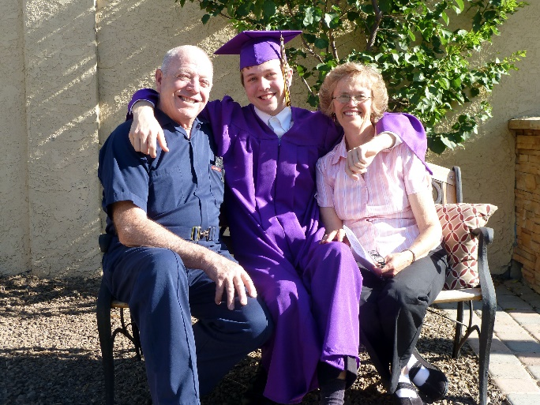 Quint has such a great personality and is so easy to talk to. As he grew older, I had some good conversations with him and I loved it. He has a talent of writing, and designing video games. He is also good looking and lots of girls would have liked to go out with him, but I think he didn’t have good self-esteem and so didn’t date much. Ken and I went down to his High School Graduation and Graduation from Seminary. We are proud of him, as school didn’t come easy for him.

Shellie has always hoped that her sons would go on missions. Garrett did, and Quint was becoming the age to go on his mission. He put in his papers, and he received his mission call to Washington DC. Ken and I went down to be with him and his family before he left on his mission. We went to his farewell talk in Sacrament Meeting and Shellie had family and friends over for dinner and desserts afterwards. He enjoyed being at the MTC, but when he got out on his mission, he had problems and wanted to come home. Shellie called and asked if we would pray for him and maybe write a letter of encouragement to him. We did, but Quint wrote back and told his grandpa that he had always done what everyone else wanted him to do, but now he wanted to do, what he wanted to do, and he wanted to come home from his mission – so he did.

Shellie found out later that his zone leaders told him that he had to bear his testimony to the investigators that he knew the church was true and that Joseph Smith was a prophet and we are led by a living prophet today. Quint told them that he “believed” the church was true, that Joseph Smith was a prophet and that we had a living prophet today, but he couldn’t say he “knew” these things. Quint was hoping he would gain a stronger testimony on his mission. They kept telling him he had to say he Knew these things were true. Quint couldn’t say that, so he came home. We were sad to hear that these zone leaders would do that, and now Quint isn’t active in the church. We were disappointed as was Shellie, but we understand and still love Quint very much, he’s a wonderful grandson.

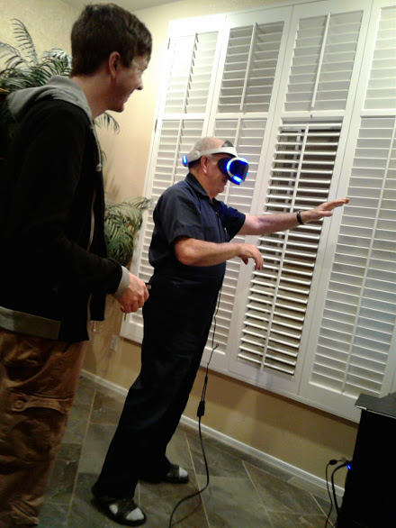 In April of 2017, Quint called and asked if he could come and stay with us for a couple of weeks or more, until he could find an apartment to share with other students, as he was planning to come to Utah and go to the Community College in Salt Lake. He told us he would gladly pay us. He has never liked living in Arizona as he hates the heat and loves cold weather. He was planning to continue living here in Utah and get a good job when he graduated. We told him we would be excited to have hm come and we wouldn’t worry about the money unless he stayed longer. Shellie drove their truck packed with Quint’s items and Quint drove his car, which was also packed. We were able to get him a storage unit where he put a lot of his furniture and stuff, and we brought the rest of it over here to our guestroom where he would be.

This was in May. Quint loved the Community College, the grounds, the professors and the students. He made some friends and was doing well. We enjoyed having him here and hearing how his day went. We learned from him.

Quint would eat dinner with us and then study and afterwards he would play video games, many of them with Kevis. Kevis was a Marine stationed in Okinawa, but they would get on with each other when their times went together, which was usually at night. **Quint has a virtual reality setup, that is really neat. You put on a headset and you are carried away into different setups and environments. It is pretty fun.** **Quint is showing his grandpa how to do it, in this picture**. We invited David Michael, his wife, Sierra and their little son, Henry, here for dinner and an evening, and also Paige and Garrett, so they could be with their cousin, Quint. After dinner, he took David & Garrett into his bedroom and they had fun with the virtual reality headset, etc. Quint also showed them the video game he is working on. They both were really impressed and said he could easily get a job doing that, as he is really talented in that field. They had a good time together. We also invited Scott and his family and David and his family here at different times for dinner so they could be with Quint. A girl, about his age, who we home teach to her and her family, saw Quint and told her parents that she would like to meet him as he is really good looking. She is a little heavy, but has a cute personality. I invited their family over for dinner and Quint was polite and friendly to all the family, but I don’t think he wants to date her. He stayed with us for the three months, but he insisted on paying us at least $100 for room and board. He wanted to pay more, but we wouldn’t let him. He was always so appreciative for everything we did for him and always told me how delicious the meals were. In fact, he raved about them, even though I knew they were not that great.

However, Quint found out that paying “Out-of-State tuition was way too expensive and he couldn’t get the grants or student loans he needed, so he was only able to be here for the one semester. He planned on continuing at the Community College in Arizona, but he didn’t. He has a good job with the Wells Fargo Bank for now, and is sharing an apartment with two other friends. One is Chandler, who has been a good friend of Quint’s for years.

**KEVIS SEYMORE**

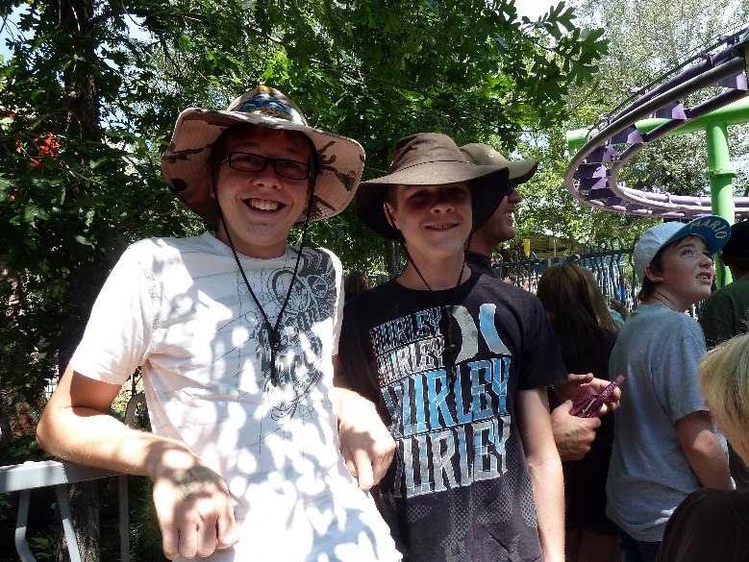Quint and Kevis have always been close as brothers. Kevis loved Quint and wanted to be with him. They played really well together, and they have always been the best of friends. Even when Quint had friends over to play cards or video games, Kevis was with them. And when Kevis had friends over, Quint was usually with them too. Yes, Kevis made some friends who loved to play “Magic”, a card game which took hours to play. They all liked to come to Kevis’s home and play there. Shellie would always have treats for them, and sometimes they would stay for dinner. Kevis and Quint have a great relationship to this day, and I’m sure they always will.

Kevis took Karate and I think he got his black belt. When we were down visiting, I would go watch him, and he was really good. I would ask him to demonstrate for me at other times and I was amazed at how good he was. He also plays the guitar and is talented with that

Ken and I went down to Arizona for Kevis’s high school graduation. It was great to be with him and his family at this special time. Kevis looked great in his cap and gown.

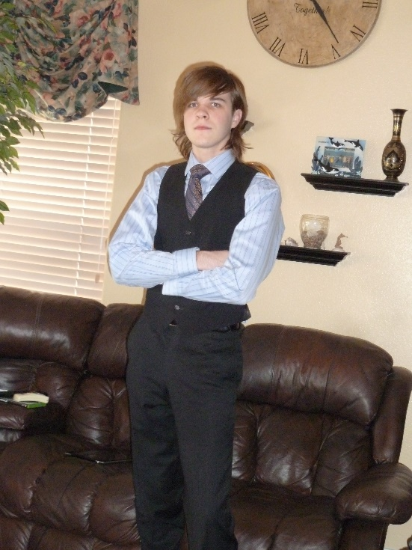Kevis didn’t want to go to college, although he was very smart and got high scores on his ACT test. In fact, colleges and universities were calling him to encourage him to enroll with them. We are not sure why he wouldn’t go to college. Shellie & Roy even told him they would pay his tuitition**. Kevis got a job at a men’s clothing store, and he was good at it. The boss was impressed at how he could talk to the men and boys and help them decide what shirts, ties, socks, & sportscoats went well with the slacks or suits they were buying. Kevis needed to wear suits, dress shirts and ties to work and he got a good discount from the store. He really looked nice.**

He didn’t work every day, so he didn’t make a lot of money, so he quit the job.

Kevis somehow likes the “Goth” dress style and appearance. They have long, black hair, wear black and have chains for belts. At first, Shellie & Roy didn’t see much wrong with it and his hair wasn’t too long and he hadn’t died it black as he knew his parents wouldn’t go for that He bought black pants, black shirts, and he wanted black boots and a black trench coat, so he got those for Christmas. The boots had chains on them.

Kevis is a very handsome young man, but he looks scary in those Goth clothes and with that appearance. He went from bad to worse. Since he didn’t look hard for a job, so was mainly just sleeping during the day and playing video games at night, and wouldn’t go to college, so wasn’t doing anything with his life, his parents finally told him, he would have to move out. Roy found some guys, who he thought were good guys, so moved Kevis in with them. Kevis got a job, but I don’t remember what it was. One night they got a call from the police that Kevis was in trouble with the police. They went to get him, and it turned out that the police got him mixed up with one of the other guys in the apartment, and they dragged him out of bed, threw him to the ground and handcuffed him. That was horrible for Kevis. Finally, when the police found out the truth, they let him go with his parents.

**Kevis decided he needed to join the Marines**. He tested high on his tests, so they said he would be in “Intelligence”, but they didn’t have an opening there, so sent him to be schooled in radio technology. The basic training was hard, but Kevis is very strong so he did good. He was sent to Okinawa, and that is where he was hoping to go as he and Quint were teaching themselves Japanese and now, he would be able to speak it. He would also be able to go to Japan at times and he loved that. I was worried about him as the Marines is a tough military group, and has tougher training than the other military, but he is doing good.

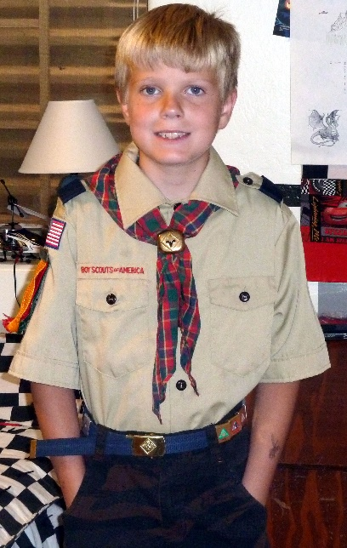**JASE SEYMORE**

Shellie thought that maybe diet would help Jase, and so they came to Utah and met with our nutritionist, Nancy Litchford, and she told Shellie about the “Gaps Diet”. That is really a hard diet and so much work to make the food they were to eat, and it was expensive also, but she was a trooper and both her and Jase stayed on that diet for several months. Jase said he liked the food his mom made for him. Shellie couldn’t see that the Gaps diet did that much for them, so eventually they got off it, and Jase likes hamburgers and other foods now. In fact, now that he is older, he cooks the best hamburgers on their grill. Jase takes good care of himself. He likes it when his parents leave for a trip, as he likes to be alone in the house. He keeps the house clean, he fixes his own food, and loves being on the computer doing “Mind Craft” and other software programs.

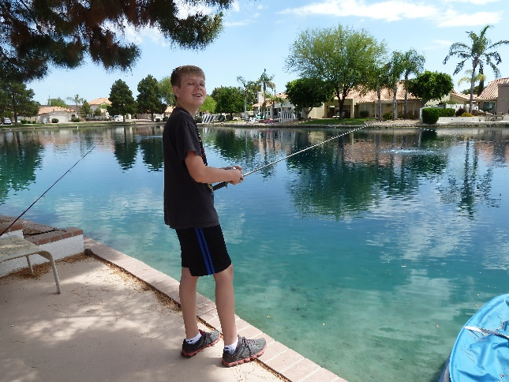 Jase didn’t do as good in public school, so Shellie put him in a Charter school. He had one teacher that was great and Jase made good progress that year, but not the other years, so Shellie home schooled Jase during his Junior High years. He did on-line classes and Shellie helped him, but it was hard. He studied from early morning until late at night and even on weekends and holidays, so Garrett talked Shellie & Roy into having him go back to public school for his high school years. That was a good decision, and Jase had done good, and he likes it as he doesn’t have to study so much – he has time in the evenings for himself and he has the weekends and holidays.

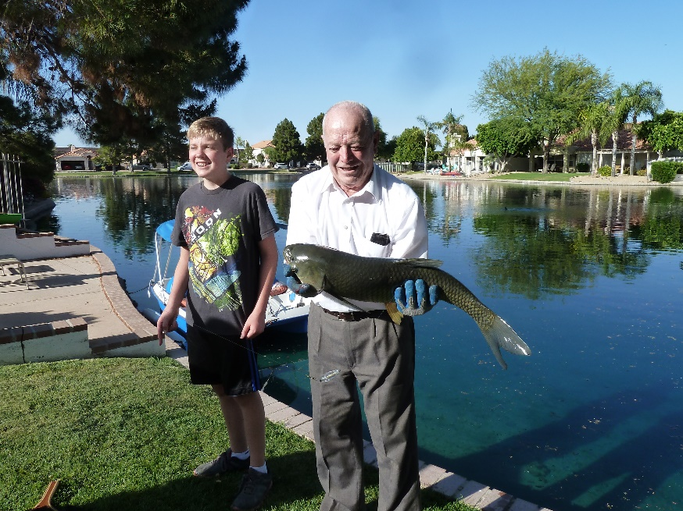 Jase knew that Grandpa knows a lot about fishing and loves it, so he wondered if Grandpa could teach him and they could fish in their lake. His mom had Ken go with her to buy the fishing pole and whatever else he needed for fishing. Grandpa and Jase did fish on the lake and they caught a large Catfish. They are good to eat, but on that lake, it was a “Catch and Release”, so they had a hard time getting the hook out of his mouth so they could release him. The whiskers sting, like a hornet, if it touches you. They fished two or three times, once in their paddle boat, and then Jase got bored with it and didn’t want to fish anymore. That was sad since Shellie spent that much money and was hoping this would be a good thing for Jase.

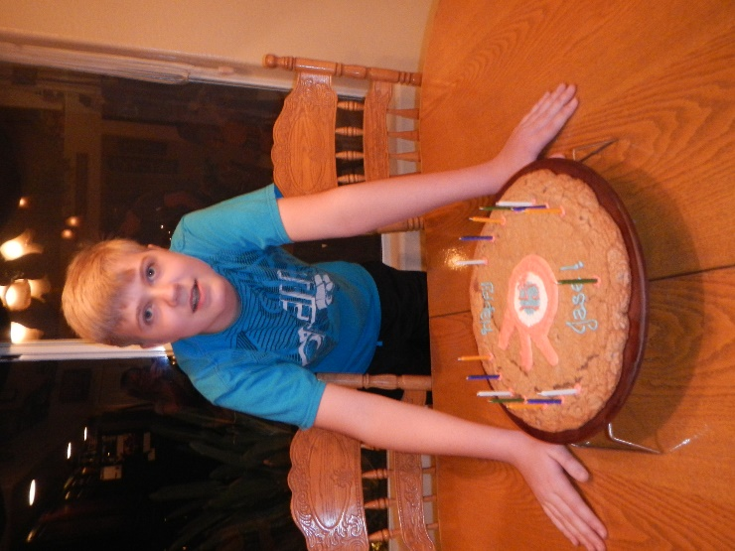Jase studied and got his driver’s license and now drives himself to school and back. He has a set route of how he goes. One time, before he got his license, Ken was taking him to school. He told Ken to go down a certain road and it turned out to be the wrong road, so Jase told him he would need to turn around, go back and start over. Ken said “Can’t I just drive over this block and be on the right street”, but Jase knew his route and wanted to go that way.

Jase is really good on the computer. He showed me amazing roller costars and other rides in amusement parts which he designed and made on his software programs. He has a 3D Printer and he is amazing at designing and making items. He has made cute things to go on picture frames and all kinds of things. Kylan does this also. Jase just designed some air ventilators for their hot tub which would cool you in the hot summer months when you didn’t feel like jumping into a “hot” tub. His dad will take his designs to people who make hot tubs as they would probably pay Jase for his designs and work. I am amazed at what Jase can do. He is such a good guy, we all love him.

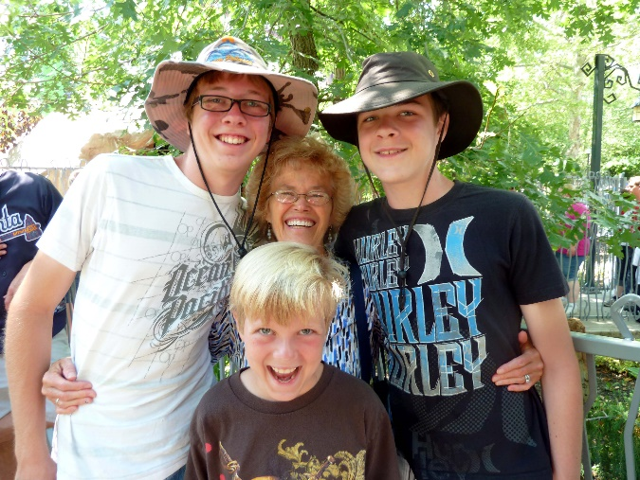**SEYMORE GRANDCHILDREN**

**Mae with her three Seymore grandsons – Jase in front, Quint on left of Mae and Kevis on the right**

**This picture was taken at Lagoon, as each time they come for a summer vacation, we go to Lagoon and many times, we purchase a bounce back ticket for the next day.**

**I had spent a week with these three, while their parents went on a vacation. I really enjoyed being with them. I left these letters for them as I left for home. They had already gone to school.**

**letters: 2013**

**Dear Quint,** you are awesome!!  Thanks for the great conversations we have had together.  Thanks for watching the movies with me.  I loved “The Gladiator” and “Singing in the Rain”.  I also liked watching “Kora.   I know you will have a great life.  You have a great personality; you are very talented and a good worker.”  Thanks for your good attitude. Thanks for loving and helping your brothers and parents.  I wish the best for you with moving out on your own and getting on with your life.  Maybe someday I will get to read one of your books or see a great video game you have made or maybe you will become a great artist.  The sky is the limit.  Be happy, help others and enjoy life as it goes by too quickly. With lots of Love, Grandma Browning

P.S. Always keep God’s commandments as they will bring you peace & happiness, not only in this life, but for all eternity.

**Dear Kev,**

You are special!  And I really mean that.  I don’t think you realize just how special you are.  Thanks for showing me your Karate moves, you are really good.  I didn’t know anyone could kick as high as you do.  I’m excited to show Grandpa this video and the ones I took at your sparing meets.  You are also talented with music and art.  You can be whatever you want to be.  If you become a director, I’m sure you will be a great one, or if you choose something else, you will be great at that.  Just realize that you can be or do anything you want, if you want to bad enough. Thanks for telling me about the series “Kora” and watching it with me and Quint.  Also, thanks for watching “Singing in the Rain” with me.  I loved seeing it again. Thanks for being so respectful and kind to me.  Thanks for helping with the dishes or anything I asked you to do, so willingly. Lots of Love, Grandma Browning

P.S. Always keep God’s commandments as they will bring you peace & happiness, not only in this life, but for all eternity.

**Dear Jase**, I’m so proud of you; you are doing awesome with your special diet and in school.  You are great!!  I’m thankful you are my grandson.   I’m glad you bought that stunt airplane; it was fun watching you fly it at the park.  Thanks for playing games with me as that was fun.  Grandma always loves to play games. Thanks for doing your homework and chores so well.  You are a good boy.  I was beaming, as your teacher at the parent/teacher conference, showed me your report card and went over it with me and told me how smart and kind you are, and what a good writer you are.  You are very talented.  I can see you becoming a great writer, like Quint.  When you grow up, I’m sure you will do well in whatever you choose to do as you are smart, good and talented.  Heavenly Father loves you; your parents love you; your brothers love you, and your grandparents love you. Lots of Love, Grandma Browning.

**DAVID MICHAEL BROWNING**

** David Michael** is a special grandson. He is the oldest child of Mike and Becky. I loved tending him when he was little. Taylor Paige was born a couple of years later and they have always been close. As far as I remember, they always played good with each other.

When Ken and I would go down to tend David & Tayler, we would sometimes go for walks and David would ride his trike and Ken or I would pull Tayler in their red wagon and we would go around their block. They had a Lego table and lots of Legos, and they loved playing with them. Sometimes it was just me going down, as Ken had to work. I would usually take them to their parks to play. As the years have gone by, we would still go and be with them while their parents went on a trip, usually a school conference that Mike needed to attend and he would take Becky with him. Ken and I would take the kids bowling at least once while we were there as we all enjoyed that. We would usually stop at the store and buy a carton of ice cream to eat later at home. We played games, visited, watched movies on TV, etc. We love these special grandchildren and were always glad when Mike and Becky would ask us to come and tend them or stay a night or more with them. We wanted to have quality time with them and make memories.

David was a sweet boy and a good boy. When he was about 9 or 10, we took him with us to Jenny’s Lake in Idaho. Ken’s boss had a cabin there and invited us to use it. When we got to the Idaho border, we had David stand by the sign and we took a picture of him. We enjoyed having him ride in our truck with us as this gave us time to bond with him, and also at the cabin. We all had a good time. I don’t remember what all we did, but I just remember that it was fun having him with us.

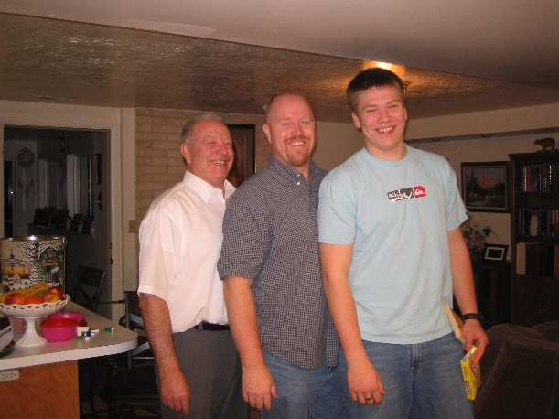It has been fun to watch David grow, and grow he did. When he was about 15, Grandpa asked him if he would like to help him roof my cousin, Randy Porter’s cabin up in the Unitas. Ken told him that he would pay him. David agreed. I asked Becky if Tayler Paige could come with us as she and I could have fun being together up there, while David & his grandpa did the roofing. She did, however, they were a little concerned as Paige would be with us during her birthday. She wanted to come, so they let her and I was glad they did. Her and I played games, fixed the meals, went on walks, rode the four-wheeler and enjoyed being together. She even helped me make and decorate her birthday cake. I had some presents for her, so we did all celebrate her birthday up there. Wow, that roof is really steep and I was worried about Ken and David roofing it. Ken is amazing at what he can do. He built stilts (I guess that’s what you would call them) which reached practically to the top of the roof. Then Ken would secure them on both sides and put a wood plank between them, so them to walk on. Thank goodness David was strong and Ken 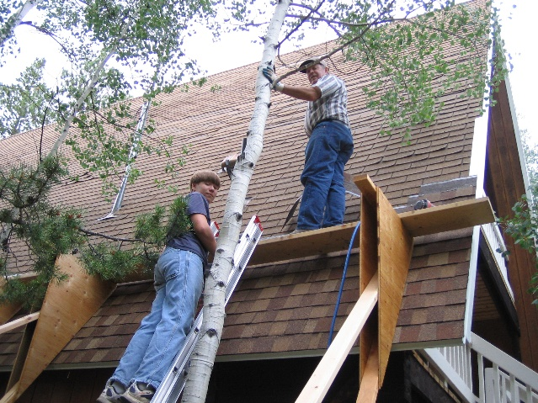was young enough and they worked together well, getting it done. I didn’t even like to watch them as I was worried, they would fall. Thank goodness David wasn’t afraid of heights, and Ken never has been, but at one point they were almost to the peak of the roof and the plank started to slip. Ken yelled at David to grab for the peak. They both did, thank goodness, and they went hand over hand until they got to the other stilt, could get on it and fix the plank so they could step down on it ******(ask Ken about this). David said “Wow, I didn’t know I could jump that fast and grab the top.” Ken agreed. They finished the roof without any accidents, and I was sure grateful. I had been praying for them. We were there about a week, I think. It was fun to be up in the mountains and yet be in a nice cabin. The cabin has a large wrap around deck, and it was fun to be out there and watch the squirrels and chip monks. I don’t know what Ken would have done without David’s help – he couldn’t have done it alone.

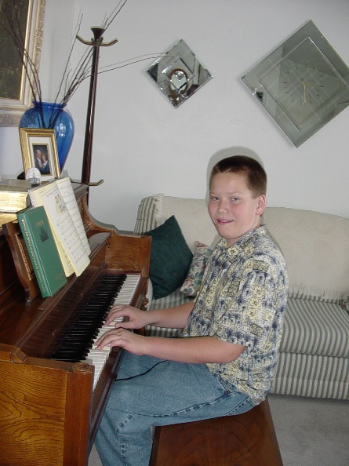He played Football in High School and was very good at it. We loved to go watch him. It’s hard to see who is who when they are in their football uniforms and helmets, but we could usually spot David, plus we knew the number on his jersey.

David has a great talent of music. He took piano lessons and learned quickly. His grandpa Stewart told his grandchildren if any of them could play the hard sheet music he had; he would give them $100. David took him up on it, and that piece was really hard, but David conquered it and got the $100. He also plays the guitar and is good at it. Whenever I went to their home, I would ask David to play one or more numbers for me, and he did. I loved hearing him play. When he was a big football player, his hands and fingers were large, but that didn’t make a difference, he was so talented.

His dad bought a little car, and he later sold it to David. I don’t know how David fit in it, but he did.

David served a mission to Africa. He came home without a testimony of the Gospel, and isn’t active in the church now. That is sad for us as Ken and I know the church is true and were hoping all our family would be strong in the church. We all have our agency and can choose the paths in life that we want. We will always love him and his family and all our other children and their families, who have left the church, as well as those who have stayed in the church. They are all wonderful children and grandchildren. They love their families, they love us, (we hope they always will), and they love others.

.

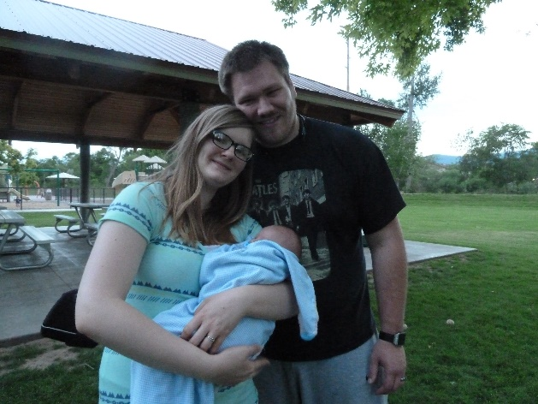David worked two jobs to save money to attend Utah State University, which he did that fall. He met a special young woman, Sierra. They dated, married and have a cute little boy, named Henry. They were able to get into low-cost housing because they were both going to the University. The home is in a nice community of home. It has two bedrooms, living room, kitchen, and two bathrooms, plus laundry facilities. They have a couple of nice parks in the community.

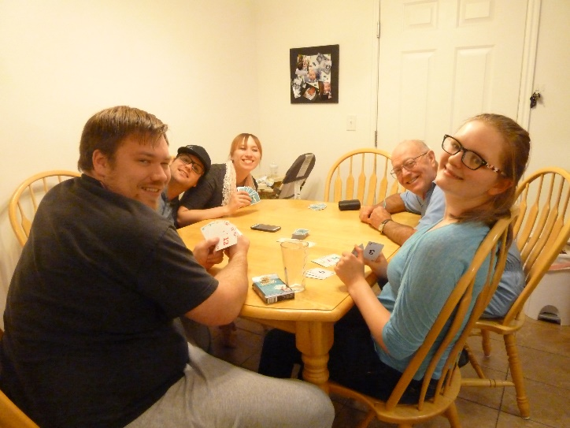Both David & Sierra are working. Sierra’s mom runs a day care for children, so Henry goes there when David or Sierra can’t be with him. In 2018 David graduated in Computer science. He was offered a good job right away since he was working part time in that field. He is what I call a “Computer Geek”. He can fix about anything that goes wrong with computers. He helps Ken and I with our computers all the time. In fact, he put on “Team Viewer”, which when I put in the code, he can be in Logan, but he can sign in to our computer to look at it, and fix it. When our laptop crashed, he was able to get most of our information from it to save it for us. We were sure grateful. He is a special grandson and we sure love and appreciate him. We invite him, Sierra and Henry to our home for dinner and games as often as we, and they, can. Sometimes he works on our computers while he is here also, which we appreciate. We have invited Paige and Garrett to come some of the times when we have invited David & Sierra. Another time David & Sierra invited Paige and Garrett to their home and also us. I brought dinner – Lasagna casserole, salad and garlic bread. We played games after eating and visiting. We had a great time.

A beautiful little daughter, Charlotte Mae, who they call “Charlie”, was born to them. This time Sierra had to have a C Section, so she had to be down and it would take longer for her body to heal. Becky was working, but could go stay and help them for the first few days. Sierra’s grandpa was able to come and help them some too. Sierra’s mom couldn’t come to stay as she has her day care, so they asked me if I could possibly come to help them. Ken came to help me and that worked out great. I was able to fix the meals, do laundry, but Sierra folded them, and I was able to do whatever else needed to be done. Ken played with Henry and Henry loved it. Ken got down on the living room floor, put together a racing car track and he and Henry played with that for a long time. Ken also took Henry outside and blew bubbles for him. I went out and it was so fun watching Henry laugh and run to pop the bubbles. We took Henry to their park sometimes also. I loved being with this special family and I loved holding little Charlie.

Sierra is a smart young woman and she graduated with a degree in speech therapy May 2019. Ken and I were able to attend her graduation and then go to a luncheon at the home they just purchased. They had Costa Vida Salads which mainly Becky prepared. I helped some and Sierra’s mom brought the dessert. We are proud of David & Sierra for working hard to graduate from the university and being great parents at the same time. They were able to go on a vacation to Oregon afterwards and Becky and her mom tended the children.

**TAYLOR PAIGE BROWNING**

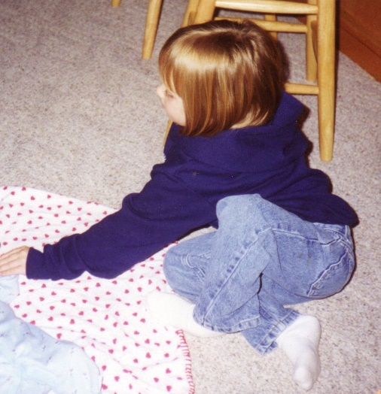Taylor Paige was a cute little girl, she was born a couple of years after her older brother, David, and the two of them have always been close. As far as I remember, they always played good with each other.

When Ken and I would go down to tend David & Taylor, we would sometimes go for walks and David would ride his trike and Ken or I would pull Taylor in their red wagon and we would go around their block. They had a Lego table and lots of Legos, and they loved playing with them. Sometimes it was just me going down, as Ken had to work. I would usually take them to their parks to play. As the years have gone by, we would still go and be with them while their parents went on a trip, usually a school conference that Mike needed to attend and he would take Becky with him. Ken and I would take the kids bowling at least once while we were there as we all enjoyed that. We would usually stop at the store and buy a carton of ice cream to eat later at home. We played games, visited, watched movies on TV, etc. We love these special grandchildren and were always glad when Mike and Becky would ask us to come and tend them or stay a night or more with them. We wanted to have quality time with them and make memories.

For years I always got

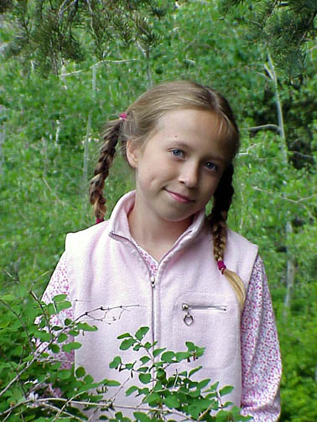 When Paige’s brother, David, was about 14 or 15, Ken asked him if he would like to help him roof my cousin, Randy Porter’s cabin up in the Unitas. Ken told him that he would pay him. David agreed**. I asked Becky if Taylor Paige could come with us as she and I could have fun being together up there, while David & his grandpa did the roofing**. She did, however, they were a little concerned as Paige would be with us during her birthday. She wanted to come, so they let her and I was glad they did. Her and I played games, fixed the meals, went on walks, rode the four-wheeler and enjoyed being together. She even helped me make and decorate her birthday cake. I had some presents for her, so we did all celebrate her birthday up there. We were there about a week, I think. It was fun for us to be up in the mountains and yet be in a nice cabin. The cabin has a large wrap around deck, and it was fun to be out there and watch the squirrels and chip monks. I was grateful that David could help his grandpa as I don’t know what Ken would have done without his help – he couldn’t have done it alone. And I was glad Taylor could be there with us.

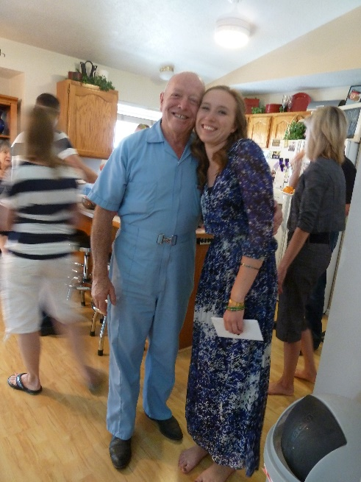 **Paige** grew to be a beautiful young woman. She is talented in interior design, so while at American Fork High School, she was able to get a part-time job with a store and did interior design for them, but in the summer, she received another great opportunity to work for a contractor during interior design for the custom homes he was building. He really likes the work Paige is doing. Paige studied hard and got straight A’s in school, so got a scholarship to Utah State University, but when she was ready to go to Utah State, she told her boss that she would have to quit. He told her she didn’t need to quit as he would furnish her with a laptop and a fax machine, and she could work, while going to college and just fax the designs back to him. That worked for both of them. She went to Utah State University and got straight A’s there. She is a beautiful and smart young woman, and works hard.

Paige met and dated a neat young man**, Garrett,** who served his mission in the Philippines. They wanted to get married, but Mike talked to Garrett and told him that Paige needed to finish her schooling and graduate. Garrett agreed, and Paige did graduate. Paige and Garrett were married in the Timpanogos Temple. Ken and I were thrilled to attend their wedding and they held their reception in a home Paige had designed. I remember they served ice cream with all the toppings out on the beautiful back lawn.

Garrett and Paige are both really adventurous, so when there was a super typhone in the Philippines, Garrett and Paige went over to help rebuild. Paige loved the people, and especially the children. The two of them have gone on several trips. They love and enjoy each other and have a great marriage.

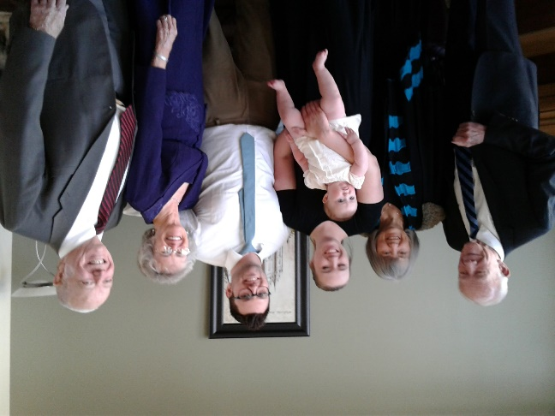**They now have a beautiful little daughter, who they named “Wren**”. She looked like Paige when Paige was a baby as she is rolly and polly too, and has a cute personality. I guess she was hard as a baby and tottler, but she is the apple of her grandfather, Mike’s, eye. Little Henry sure loves his grandpa too, and of course his grandma. Becky is so good to her grandchildren.

Paige texted me one day to see if I wanted to come down and go to the Family History Library with her, as she knows I am a Family History Consultant. Ken wanted to go also and Paige and Garrett bought a new home in Saratoga Springs, which is on the west side of Provo Lake. She invited us out to see her home and then we would go from there to Thanksgiving Point where we would eat lunch and then go to the Family History Center. When we got to Paige’s home, Wren was still asleep, so Paige gave us a tour through her home. It is really nice; we are happy for them. When Wren woke up and Paige brought her out, Wren saw me and reached out her arms for me to take her. I did and she cuddled up and put her head on my shoulder. I loved that. She is a heavy little girl, so I couldn’t stand very long holding her, so I sat down, but she still held tight to me, and I loved it. We soon left and went to a cute restaurant and went out on their large patio and ate lunch there. It was so pretty there; the food was delicious and we enjoyed being with Paige and Wren. Afterwards we went to the Family History Center where we went on a tour, and then spent a few minutes on the computer, but Wren was getting fussy so Paige decided she needed to leave and take her home. The tour took longer than I thought and I think Paige would have rather forgo the tour and have me show her more on Family Search. I should have done that.

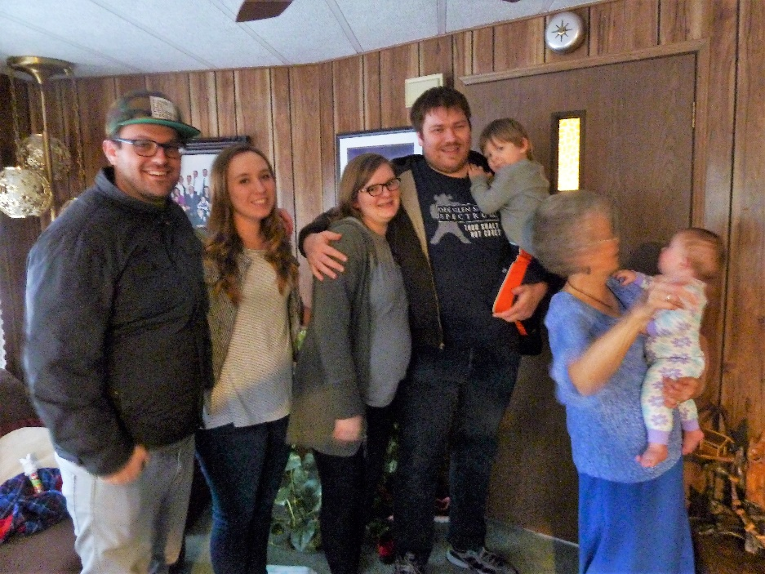

Ken & I invited David, Sierra & little Henry, and Paige, Garrett & little Wren, who I am holding, to dinner and games. We had a great time. We love these special grandchildren and their children, our great grandchildren.

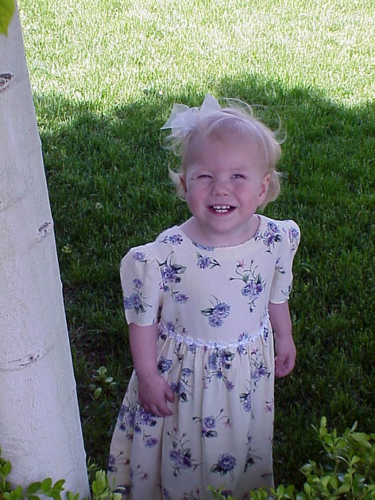

**MADELINE MACKAY “MADDY” BROWNING**

Becky wanted to have more children, as at the time they just had David & Tayler, but Mike said they couldn’t afford more children. He finally told her that if he went back to school and got a Masters Degree so he could go into school administration, he would make more money and they could have more children. They did that. Mike was able to get into an accelerated one-year program. That was a hard year, but he did it. They then had another beautiful little daughter, who they call, Maddy. She has a cute personality, and she was a little talker, but it was fun to listen to her. It has been fun to watch her grow from a cute little girl to a beautiful young woman. Becky was always good to let Ken and I know when the girls had a ball game, a piano recital, a choir concert, etc., and we loved to come to support them and we always enjoyed it. I loved watching our grandchildren perform in whatever talent they had.

As Maddy grew, she loved little children, and you would see her holding a little cousin or playing with the children at a family party, barbecue, holiday camping trip or reunion. The little ones loved Maddy back. They loved the attention she gave them, and the fun things she did with them.

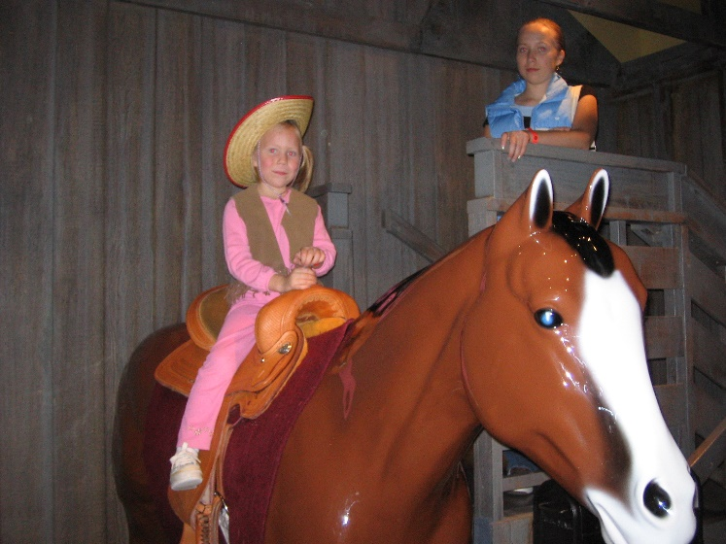I took these special grandchildren to Dinosaur Park in Ogden, at least once most summers. I would buy a Grandmother’s pass, which entitled me to take all my grandchildren there as often as I wanted for a year. I bought this pass every year for many years. With These children living farther away – American Fork, I didn’t get to take them as often as the ones who lived closer around us, but I also took Paige, Maddy and Jessie to the “Children’s Tree House” in Ogden. It has so many fun things for children to see and do there. This picture of Maddy, on this horse, was taken there. Paige is standing by her.

Maddy also loves doing hair, she has decided to become a beautician. She did her own hair and did Jessie’s for a long time, but then Jessie didn’t want her to do it any more, she wanted to do her own. Maddy is very talented and she has beautiful, long hair and can arrange it in many styles.

 Maddy decided she wanted to join the “Color Guard” at American Fork High School. It was expensive for the costumes, equipment, etc. Mike told her he would pay half, but she would have to pay the other half. This was good for Maddy, because she loves food and had put on some weight, but now she was exercising. The bad thing is that their coach is a perfectionist and always expects to take first place in their competitions, so they practice night and mornings, sometimes on Saturdays and sometimes on holidays. They are really good, and they do take first place. Ken and I have watched some of her competitions and it is great to watch Maddy perform, because of course, our eyes are on her. She was chosen Captain both her Junior and Senior years.

**JESSICA JO “JESSIE” BROWNING**

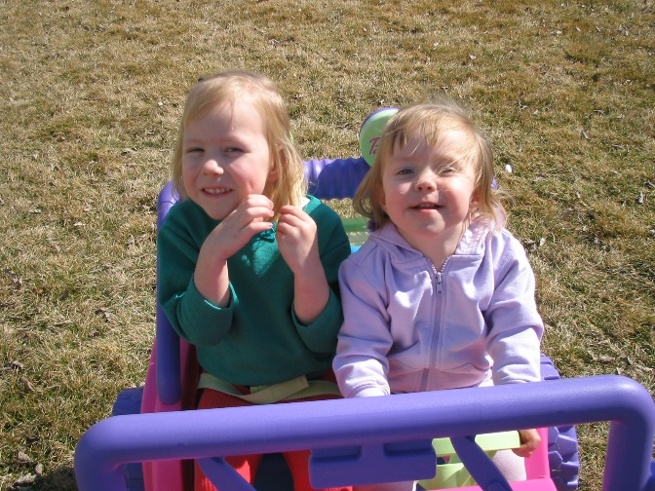Jessie was born while Ken and I were on our mission, in fact it was just shortly after we left. Becky had made the comment that maybe we should have waited that much longer to go, so we could be here when Jessie was born and to see this new little granddaughter. Jessie is only about 18 months younger than Maddy?? Now it is like Mike & Becky have two families as there is several years between David & Paige and Maddy and Jessie, but Paige was so excited to have two little sisters. She would play with them, take them places, fix their hair, etc.

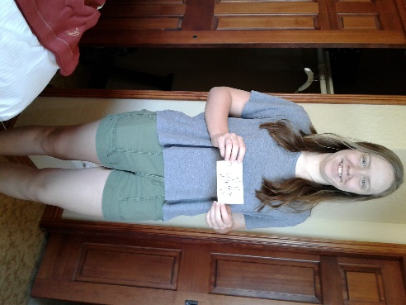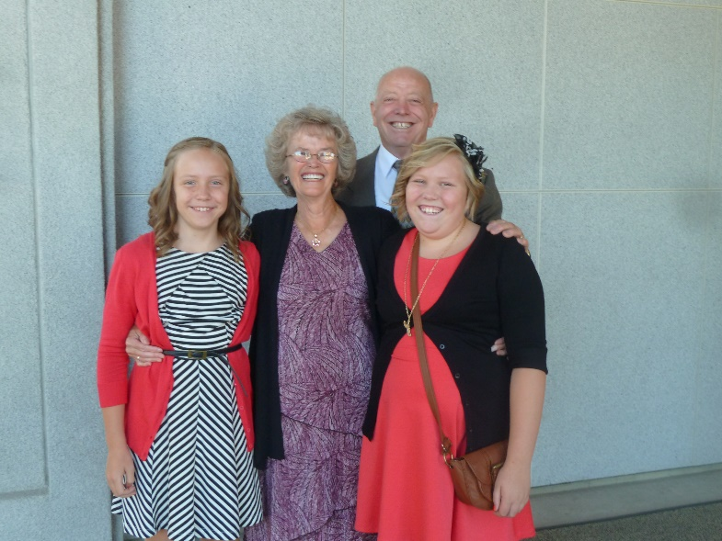Jessie was really shy growing up. She and Maddy played together and had fun most of the time. I remember tending them and watching them dance to music. Sometimes they would put on costumes, and sometimes they would have instruments made from pots and pans, etc. As they have grown into young women, however, they don’t get along as well. Hopefully that will change. They are both special young women. It has been fun to watch Jessie blossom as she got older and took drama classes and was in plays. She loved it and now isn’t shy. When Ken and I have been visiting, or when we have stayed with them, while their parents went on a trip, I enjoyed talking with both girls. Jessie was in several plays and now she helps with the props. We went to her plays and she did well. Both girls were in choir also, and Becky would let us know, and usually she would have us come for dinner and then we would go to the concerts, recitals or plays. Becky is a wonderful cook, so we surely enjoyed that too.

Jessie went to the Junior Prom, Maddy did also. The boy Jessie went with has been a good friend of hers for several years. He is shorter than Jessie, but that doesn’t matter.

**TYLER DAVID BROWNING**

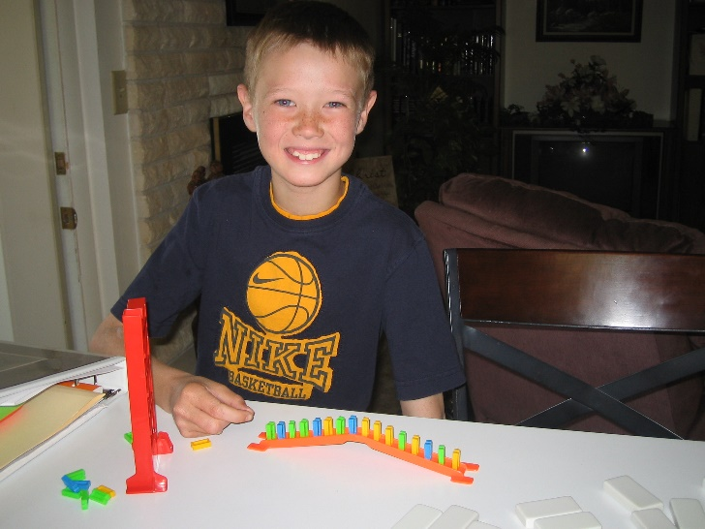Tyler was born in Idaho Falls, Idaho. He was such a cute little guy. We loved visiting that special family. When Emily was born, Ken and I went there and tended Tyler while his dad went to visit Shauna and Emily at the hospital. We took Tyler to a fun activity center and he and Grandpa had fun playing the video games. David had a riding lawn mower since they had a large yard, and Tyler loved riding on it with his dad, so Grandpa thought he would like riding on it with him also, but “no” Tyler didn’t know Grandpa that well and so he was afraid to get on it with Grandpa. Tyler was pretty young at that time. Tyler was such a good big brother and he and Emily have always been close.

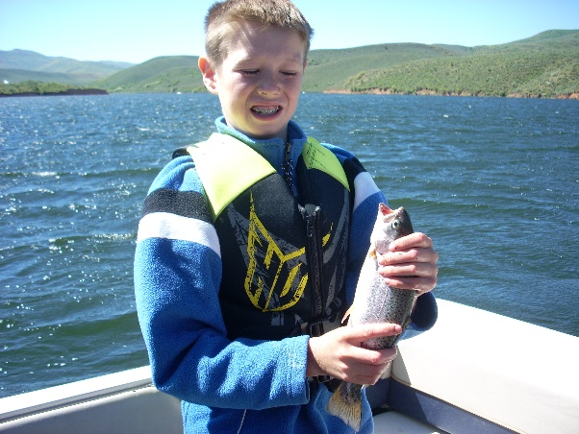David & Shauna bought a beautiful home in Enterprise, which is near Morgan, and moved down so they could be closer to family. David was able to transfer down with his Pharasuitical company. David & Shauna didn’t go on many trips just the two of them, they usually took their children with them, so Ken and I didn’t get to tend these children as often. One time, when we were tending them, it was winter and we had snowmobiles. We took them up, and gave the children rides. They thought that was great fun. We were all dressed warm and we also went sleigh riding. As the children grew, and we had our boat, we would take them fishing at East Canyon Reservoir. Ken would teach them how to fish. We didn’t always catch our limits, but we had a good time. Sometimes we would take our lunch, and we always took lots of water and snacks, as we would stay several hours fishing.

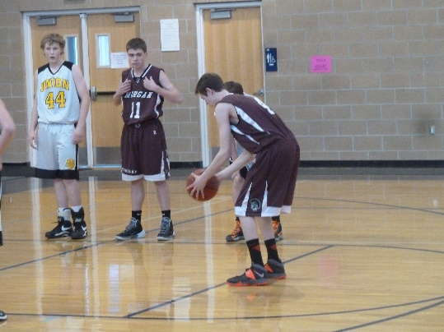Tyler was always very good at sports. He started playing soccer, and then baseball, and later basketball and track as he got into Junior High and High School. Ken and I would go and watch him play as often as we could, and we loved watching him. He played on the Junior Varsity basketball team and was very good. I don’t think we missed any games. He could have been on the basketball varsity team at Morgan High, but he didn’t like the varsity coach and he was taking hard college & honor classes. He wouldn’t have time for all the practices and games and still get good grades in these classes, so he didn’t play his senior year. We were a little disappointed, as we loved to go to his games and watch him play, but we understood and we’re sure it was the right decision. Tyler also had motorcycles and he was very good at it. He and his dad would go riding up in the hills, behind their home. In fact, they owned part of that hill.

Tyler graduated from High School with top honors. We were proud of him as we watched him receive his diploma. He got straight A’s in school. He studies hard and it pays off

Tyler always gives us hugs when they come to visit or when we go there, no matter where he is at the time. All these grandchildren do that and it makes us feel loved. If we ever need help with something we are doing, we know we can call Tyler and if he has the time, he always comes. Connor and Kylan do also. Tyler stopped by one day when he was out this way, during the summer, and we had a good visit. We were excited that he did that.

Tyler got a Presidential Scholarship at Weber University and he is at the top of his classes. He is going into Medicine, like his dad. In June 2019, he was chosen one of 100, out of 1500 applicants to go to the University of Nebraska for an internship to do research in organic chemistry. He is there now and is enjoying this experience and doing well.

**EMILY HOPE BROWNING**

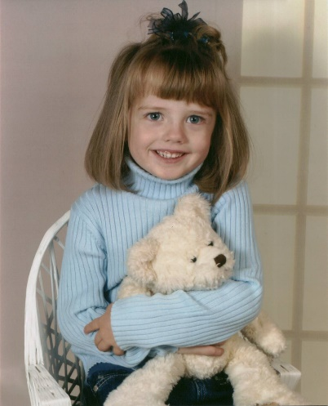Emily was such a beautiful little granddaughter, and Tyler was excited to have a sister. He played with her when she got older, and they had fun together. I remember watching them, when they were young, and playing and they were so cute. One time, when we were visiting them up in Idaho Falls, I taught them to play “Mother May I” and we all laughed and had fun playing that. From then on, when we would visit, they asked if we could play “Mother May I”. I also taught them to play “Old Pig” and they liked that game also. Tyler and Emily have always been close and that has been great to see.

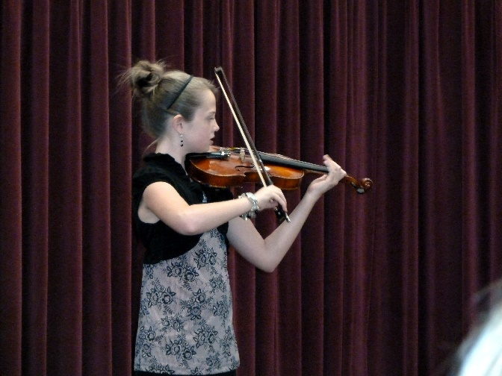Emily played city soccer for a few years and was very good. When our family would have a barbecue in our back yard in Clinton and play volleyball, she played and liked it. We also play volleyball after our Thanksgiving dinners, which are held at our stake center. Emily would have liked to play high school volleyball, but it is really competitive, and she didn’t start playing soon enough.

**Emily started learning to play the violin when she was young and now, she plays proficiently**. Ken and I have always gone to her violin recitals and we love hearing her play, and were proud of her. She plays at our Family Christmas parties also. When we are staying with the children, I ask her to play for me, and she does. We asked her if she would play her violin in our ward sacrament meeting, and she said she would. We set a date with her and the ward music scheduler and she did so well, that many members told her how well she did and how much they enjoyed hearing her play. For several weeks after, many members would express to Ken and I how they enjoyed having her come and play and asked if she could do it again. We were proud of her. David & Shauna invited Ken and I to go on a road trip with them to California and end up at St. George, where Shauna’s parent’s have a condo there. Emily met her violin teacher and the rest of the class at Tuacon, where they performed a concert. We loved watching Emily as she is really good on the violin. She took lessons later from a teacher in Layton, who taught her how to fiddle, and she is so good at that also. After the concert, we had tickets for the play. Tuacon is an outdoor theater and is really amazing and so are the plays.

Tyler and Emily had summer jobs cleaning the Northern Utah Dermatology clinic, where their dad works. They worked good together and Dr. Harris and David were pleased with how well they did. When Tyler & Emily were in high school, they rode together to school & back. I have always been thrilled at the wonderful relationship they have together and also with Connor. After Tyler graduated from high school and was in college, Emily got a summer job training horses and teaching people how to ride. She loves horses.

**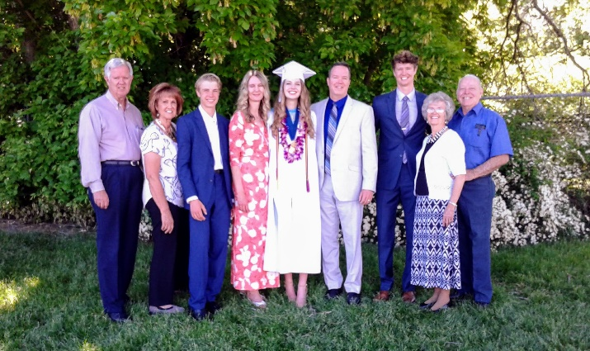****Emily graduated from High School in 2018.** Emily also got presidential scholarships as she always got straight As, and she choose to go to UVU in Provo. We went to her high school graduation and were excited as she was handed her diploma. Afterwards, David & Shauna took all of us, including her other grandparents and some friends of theirs, who came to support Emily, out to lunch at Olive Garden Restaurant in Riverdale. For Emily’s graduation gift from her parents, she choose to go to a horse ranch in ?? (another state) where you stay, eat and ride trained horses wherever you choose. They have lots of land covered with trees and Emily and her parents had a wonderful time. Emily had her mom come to where she was working, (before they left) so Shauna could get used to horses and Emily taught her how to ride and enjoy them.

June 2019 – Tyler just finished his second year at the Weber State University and Emily finished her first year at UVU. They both had top grades. They are smart, but also diligent at studying.

**CONNOR DAVID BROWNING**

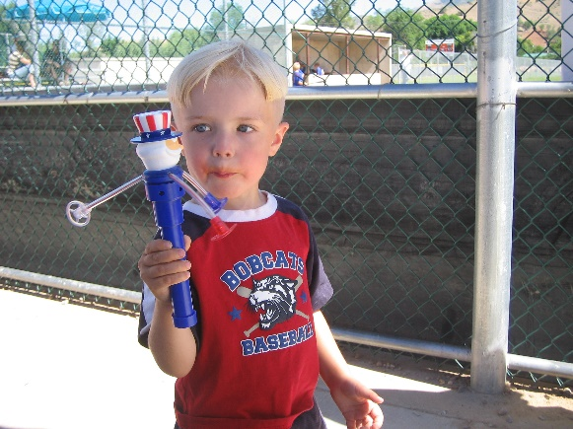Connor was born while Ken and I were on our mission to the Philippines. He was a beautiful little blond baby. When we returned from our mission and were living in Clinton, I tended Connor one day a week while his mother worked as a nurse. His other grandma tended him one day a week also, and Shauna was able to put him in a day care at the hospital the other two or three days. I loved that little guy. Sometimes they would bring him to our home in Clinton, and sometimes I would go to their home in Enterprise (Morgan County). We would go on walks, go to the park, play games, especially marbles & Parcheesi. It has been fun to watch him grow.

When I would take him with Tyler and Emily to Dinosaur Park, when he was little, and in a stroller, he was scared at first because of all the Dinosaur noises that were there. Ken went with us some too. But as he grew older, he loved going to Dinosaur Park. I continued to take them each year until they became teenagers and I was amazed that they still wanted to go so I asked their mom, since Dinosaur Park is mainly for young children. She said “Oh, they go because they like to be with you.” I was thrilled that they wanted to be with me even though Dinosaur Park wasn’t that fun for them anymore. When I would take any of the grandchildren there, we would either get ice cream at the gift shop, or stop at the gas station nearby to buy them. Most of the time, we would go about 10 am and take our lunch with us. I sure enjoyed being with my grandchildren.

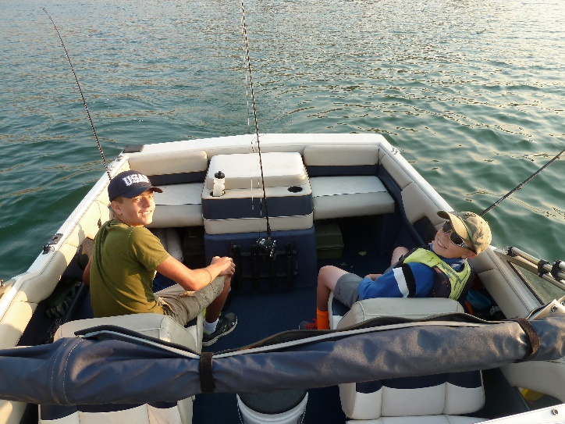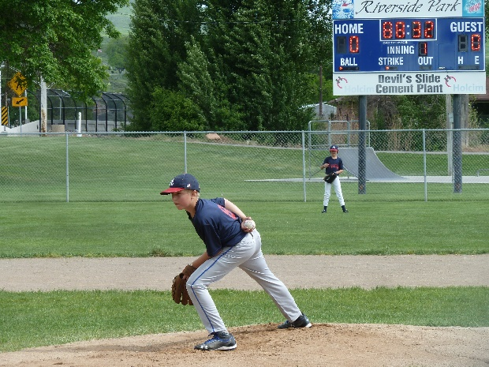 Connor is now 15 (2019). He is very athletic. He played Soccer and basketball growing up, but his favorite sport was baseball (where he was a great pitcher, as well as other positions). We loved to go to his games and watch him play also.

Connor and Kylan have always enjoyed being together, and they have a great relationship even though Kylan is about four years older than Connor. Actually, Tyler is closer to Kylan’s age, but their personalities didn’t click, where Connor and Kylan’s did. Ken and I have taken Connor & Kylan fishing, usually on East Canyon Reservoir. We have taken Tyler, Emily also, but not as often as Connor & Kylan.

Connor loves to go skiing or snowboarding, and is very good at it. His parents have bought him a season pass to Snow Basin Ski Resort, for several years, for Christmas. He has a friend who goes with him, and their moms take turns dropping them off for the day, and picking them up at the end of the day. Connor broke his shoulder bone last year as he was doing special stunts on his snowboard. He is also very good on the wakeboard, when they go to Pine View Reservoir in their beautiful ski boat. He is a good-looking young man and has many friends.

I He is always so sweet to us, and we love him.

**KYLAN BROWNING**

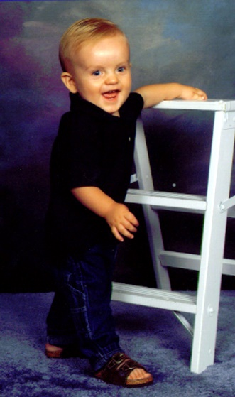Kylan was born when Scott was going fulltime to Weber College and working fulltime. We sure had to admire Scott. He needed to work fulltime so they could have insurance, since Mishelle had had cancer and had gone through 8 months of Chemo. The doctor told them to wait two years before trying to send for a baby so the Chemo could get out of her body. (Anyway, I think that was the reason.) They were excited when she got pregnant with Kylan, and we were all excited when he was born. He was a cute little guy. I loved holding and tending him. They invited Ken and I to their apartment when he turned one year old, and he loved his birthday cake. The next year we went swimming with him and his parents for his birthday and he loved that.

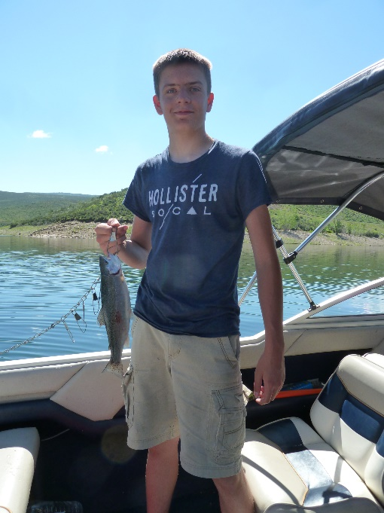**From the time Kylan was three years old, he loved airplanes**. When an airplane would fly overhead, he would look and get excited. His parents had a computer and bought a software program where he could fly airplanes. The first program or game was kind of easy, but we were amazed at how he could fly them. He then got a simulator program and he was amazing at that. As he grew older, they bought him RC Airplanes, and it didn’t take him long to know how to fly them, and they would go to parks or schoolyards to fly them. We went with him and his family to watch him fly them many times. He continually learned more about airplanes and when we were be together and he would see a plane overhead, he would tell us what kind of a plane it was. When we moved here to Monte Vista, he loved to go to the storage shed, sit on the top of our camper and watch the planes come and go. He has an app on his phone which told him when the planes were coming in or leaving. Kylan has drones also.

**Ken has taken Kylan fishing** and he loves it and enjoys being with Ken and I, or when Ken has taken his friend, Ron Graf or my cousin, Randy, but many times if I was going, we would take Kylan and Connor. One summer, when Kylan was about 15, we had reservations at Payson Lake. Scott & the family couldn’t come up until the weekend, but Ken and I wanted to stay the week. We invited Kylan to go with us, and he was happy to come. Ken and Kylan would walk down to the lake and fish by the shore. Sometimes I would come down later, with a lawn chair to watch them. We had a great time with Kylan and glad he could come with us.

**It is now 2017 and Kylan is a senior,** he has his driver’s license, dates some, still loves RC airplanes and goes to the fling field most Saturday mornings and flies his planes and drones (many of which he has made himself). He wants to become a pilot and I hope he can, and I will be surprised if he doesn’t.

**Kylan is very talented musically. He doesn’t read music, as he plays by ear and is excellent at it**. He plays the piano and is incredible at it. He was in the Jr. High School and High School bands and played percussion. He could play all percussion instruments and was really good. When we go to their home, many times, I would ask Kylan to play the piano for me. I love listening to him play.

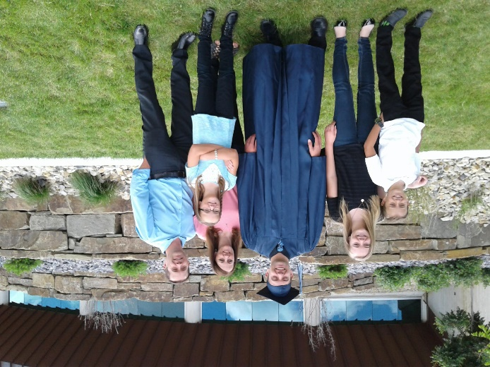**2018 Kylan graduated from high school and is now in schooling to get his pilot’s license**. He also works at an RC store in Roy to help make money for his schooling. He is a great guy. He and I have a great relationship. He is so easy to talk with and fun to be around. If we need help with something, if he isn’t working, he will come to help and if he is working, he will tell us when he can come. We sure appreciate him. His dad (our 3rd son) is like that too. He is always willing to help us. Ken helps them at times also. It is **2019** and Kylan is still working at the RC store and almost has his pilot’s license. Then he will keep flying until he has enough flying time and schooling in to become an instructor. Then he can make money to help him become a commercial pilot. We sure hope it works out for him, as it is so expensive to rent the planes and pay for the fuel.

**ASHLEY BROWNING**

We were excited when Scott & Mishelle announced that they were having another baby and it was a daughter. Ashley was such a beautiful little blond, and she had such a cute personality. She and her cousins, Maddy and Jessie are around the same age, so they have always had fun together when we would be camping or having family parties, barbecues, our family reunions and holidays, They stayed at each other’s homes sometimes during the ****summers, and I would invite them to our home, especially when we lived in Clinton and they had fun at the park across the street and playing on the big rocks on the hill. As they have grown older and they are busy with their school activities and jobs, they haven’t done as much together, but that is what happens when we grow up, and we develop different interests. I was the same with my cousins.

I loved taking Ashley and her siblings to Dinosaur Park in Ogden. It is a fun place for children, and even when Ashley and Kylan and I thought they wouldn’t want to go, so I asked Mishelle if I could take the twins, she would call back and say Kylan and Ashley would like to go, and would that be okay. I was happy that they wanted to go and we had great times together.

When Ashley was in elementary school, she didn’t want to do her homework and I remember seeing Scott ran after her, throw her over his shoulder and make her sit and do her homework. Well, that soon changed and Ashley became the opposite. She realized how important getting good grades is, and she wants to get a scholarship to go to college, so she always does her homework faithfully, in fact, she has even turned down going skiing with her family as she didn’t want to miss any school. She has gotten straight A’s, I think, from the time she was in Junior High. She is very conscientious, and that is great!

Ashley and Kylan didn’t get along when they were young. Kylan would tease her and she would scream and cry. They would yell at each other, and when we were around, it hurt our ears. As they have gotten older, they have become good friends, and that has been fun to watch. I used to tell Ashley that this was the way my older brother, Hal, and I were. He teased me unmercifully when we were young, but we became good friends when we got to be older teenagers, so I told her that would probably happen to her and Kylan, and thank goodness it did.

Ashley loves Legos and gets different sets at Christmas and for her birthday and it doesn’t take her long to put them together. I bought a small tote of Legos from a yard sale and when these grandchildren came, they loved to build with them, especially Ashley and Kaden. Ashley also loves playing “Mind Craft” on the computer and she is very good at it. Kaden and some of her cousin’s love Mind Craft also – Jase, Ben and Matt.

Ashley is such a sweet girl and as she grew older, some girls haven’t treated her like they should, and I have watched that cute bubbly, confident personality which developed into some low self-esteem, and she is shyer. I have felt bad about that, but as she continues to get older, she still has friends and especially one guy friend. I’m sure he really likes her, but she says they are just really good friends. Now in High School, he picks her up for school and brings her home after, and they along with other friends get together and have fun.

Ashley has a sister, Kaitlyn and Ashley is good to Kaitlyn and they have fun.

**Ashley is a Sophomore** at Layton High. She is, and always has been, a “Straight A” student. Friends are a problem this year because the Jr. High School, where she attended, branches out to several different high schools, so depending on where her friends live, is where they go to high school. This has made it hard since most don’t go to Layton High, where she goes. She has a Hispanic friend, which Scott & Mishelle are concerned about. I sure hope she can find good friends that will pull her up, not pull her down. Ashley is a beautiful, good, sweet girl, and I love her very much. I have taken her out to lunch occasionally and we have gone on walks. I love to hear about her life and how she is doing. I wish I could do it more with our grandchildren, but time goes by so fast and we always have so much to do. I just have to decide I am going to do something with these grandchildren, either take them to Dinosaur Park or to the Park, go watch Kylan fly his planes at the flying field, be with them while their parents go out, etc., and set a date and time. I wish I could have don more with all of them, but guess I have done the best I could.

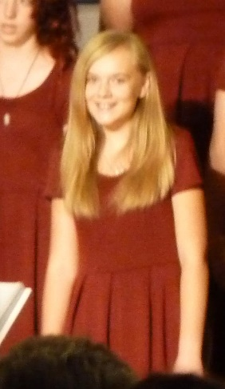Ashley has a pretty voice and has been in choir. This past year (2018 -19) she auditioned for “Lace”, the girl’ special choir. (Jeff was in “Lyrics” the boy’s special choir) They do special chorography as they sing and they are fun to watch. Sometimes Lace & Lyrics are together in certain numbers and they are really good. We loved going to her performances. She doesn’t want to be in it for her senior year, for two reasons. She doesn’t like the choir director and she is taking hard honor and college classes and doesn’t feel she has the time for choir. Those are good reasons, but I will miss going to them.

.

**KAIDEN BROWNING AND KAITLYN BROWNING**

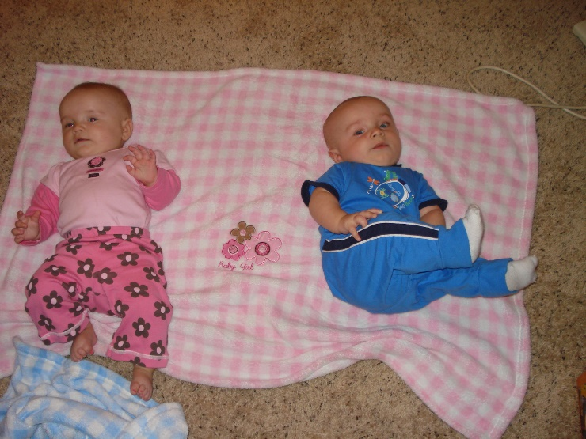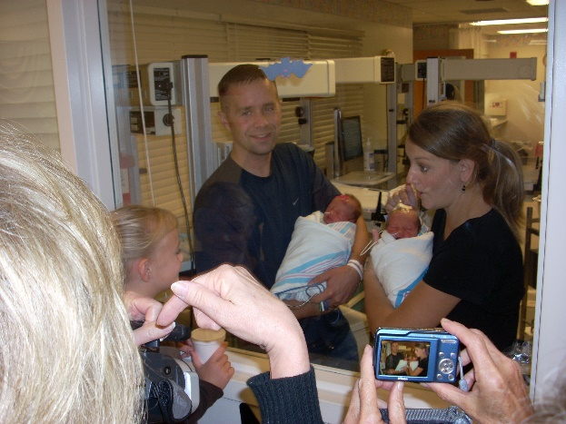Scott and Mishelle wanted more children, but Mishelle couldn’t get pregnant. A few years went by and finally, the day came she found out she was pregnant, and they were so excited. They asked Ken and I if we could come and be with Kylan and Ashley while they went for the ultrasound to see whether the baby was a boy or a girl. When they came home, they were both stunned as they found out they were having TWINS – a boy and a girl. When they told Kylan and Ashley, Ashley wasn’t surprised and she said “I know because I prayed to Heavenly Father and asked him if we could have a boy and a girl. I knew if it was a girl, I would be happy to have a sister, but Kylan would be sad not to have a brother, and if it was a boy, Kylan would be happy, but I would be sad not to have a sister – so Heavenly Father answered my prayer.” I loved it when Ashley told me, but she said her dad said it was only a coincidence. I told her “No”, that Heavenly Father loves little children and he answers their prayers. The twins were in ICU for a while, but they did well and it was great when we were able to hold them. We did go to the hospital and Scott held Kaden and Mishelle held Kaitlyn at the window for us to see them.

I enjoyed tending the four grandchildren and watching the twins. They would be on a blanket on the floor and Kaitlyn would roll on top of Kaden sometimes as she was more active and has always been larger than Kaden. Kaden would be playing with a toy and Kaitlyn would take it away from him. He didn’t seem to mind much and would just pick up another toy. Sometimes he didn’t like it though. Kaden has beautiful long eyelashes. They are both adorable. I’m sure it is fun to be a twin as you always have someone to play with or be with, especially when you are younger. If Kaitlyn couldn’t find Kaden, she would worry. This picture is of the twins in Grandma’s jackets as they wanted to go outside and it was getting cold. They look pretty cute.

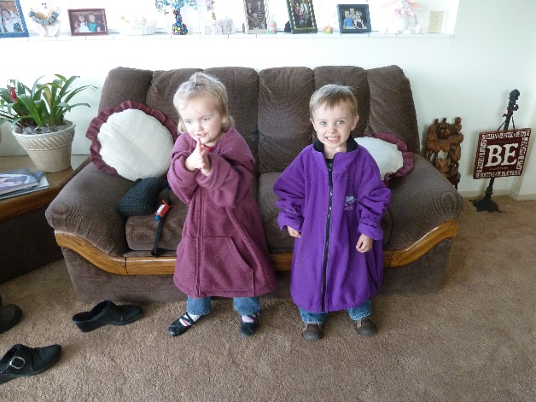As they have grown, they have their own personalities and their own interests. Kaitlyn loves to draw, make bracelets and necklaces out of beads, and go to yard sales with her mom. She finds all kinds of treasures and for hardly any money. Kaden goes sometimes too. Kaden likes to play with Legos and build things. He also likes to be on the computer on “Mind Craft”, and he loves video games, and watching You Tube videos. When they come to our home, we sometimes play “Old Pig” and other games, but they also like to play “Marbles” and I get down on the floor with them, we pull a string into a circle and we use our special marble to hit others in the circle. We get to keep the ones we hit, and the person with the most marbles, wins.

We usually take bread when we (the twin and I) go the Layton Park, so we can feed the ducks and geese who are in the park. As we walked along the river path and fed the ducks, there were geese on the lawns and so we fed them. They came closer & closer to us as they wanted more. Finally, we headed back to the car as we were getting nervous as geese can bite. They kept following us faster, so we threw lots of bread to them and ran for the car. We crossed the road and they were still following us, but finally they stopped and went back. Wow! We made our escape.

It is always fun when Scott, Mishelle and their children have been here or when we have had the kids come here while their parents go on a date, etc. I look around the front room and always see that Kaden has moved the two Swans, on the end table, together so they form a heart. He usually also closes the door on the picture frame of Ken doing carpentry work.

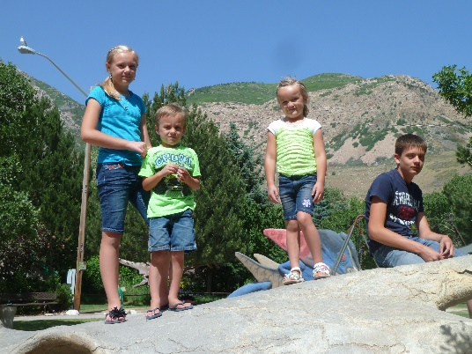It is fun to see that Kaitlyn has left us cute notes as she gets post-it notes from our container or asks for other paper. Her and Kaden also draw pictures on our white board and maybe times I take a picture of them to save them as they are so cute with picture and words.

I have taken Scott & Mishelle’s children – Kylan, Ashley, Kaden & Kaitlyn to Dinosaur Park many times. Even as Kylan and Ashley got older, they still wanted to go so we have great memories of having fun at this park.

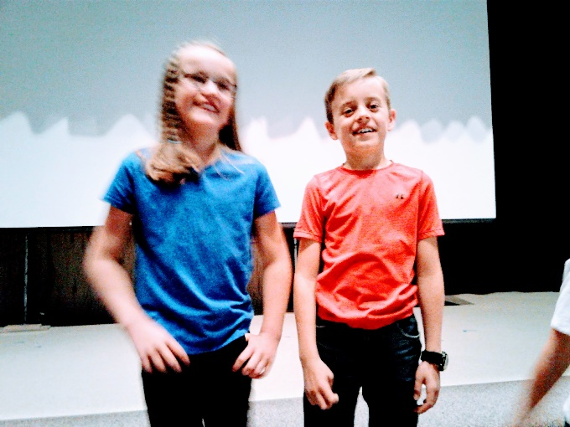**The twins are 9 years old and they are very active.**  They are loud at times and it hurts Ken’s ears. They invite me to go to “Grandparent’s Day” at their school, and I enjoy that time with them. We watch them for Scott & Mishelle at times. We play games, go to the park or school playground, or go for walks. I like to take them to the Layton Park where we can feed the ducks and go on walks, and afterwards we usually go to McDonalds for treats. The twins haven’t been baptized as Scott has lost his testimony, (so have Jeff & David). He doesn’t want them baptized. That sure makes Ken & I feel bad, as they need to be taught the gospel at home and at church, so they can gain a testimony which will help them find peace and happiness in this life and in eternity, but we respect Scott & Michelle’s wishes, and will just always love them all as they are great parents, wonderful to us and to others. I love the twins, as I do all our grandchildren. They are cute and fun to be with.

**BENJAMIN DAVID “BEN” BROWNING**

****Ken and I were excited when Ben was born. We were excited to have another grandson, but we were also excited that he was born on our anniversary, the 19th of June. This was our youngest son, Jeff, and his wife, Gail’s first baby. They named him Benjamin David and called him “Ben” after a good friend of Jeff’s who lived with us for a few months in Layton. He was a great guy and we enjoyed this Ben living with us and Jeff and he got along so great. Our grandson, Ben, is special in many ways.

Jeff & Gail had been separated for a few months, and Jeff had asked to be transferred to their plant in Ohio. Jeff & Gail talked on the phone a lot and took a marriage counseling class on life and discussed it together over the phone. They realized they loved each other and wanted to be together again, but they would need to work things out. Jeff came home for a visit and stayed with us for a few days. He invited Gail and the children to come here, and their cute little son, **Ben**, **wouldn’t let Jeff out of his sight**. Jeff was cute to play him and wrestle with him, but if Jeff walked into the other room or went to the bathroom, Ben was right behind him. He loved his dad so much and kept saying “**My Dad, My Dad”.** It just broke my heart, as at that time we didn’t know if they would get back together. When Jeff walked Gail and the children out to the car for them to go back home, little Ben kept saying “Come with us, dad, come with us.” Gail told him that dad couldn’t come home with them tonight and he started to cry.

Ken and I took our tent trailer, and Jeff and Gail took her mother’s tent and we went to Zion’s National Park when Ben was about 18 months old. Ben loved playing in the dirt with toys, containers and spoons. We had to block that area off with our truck and their car as we 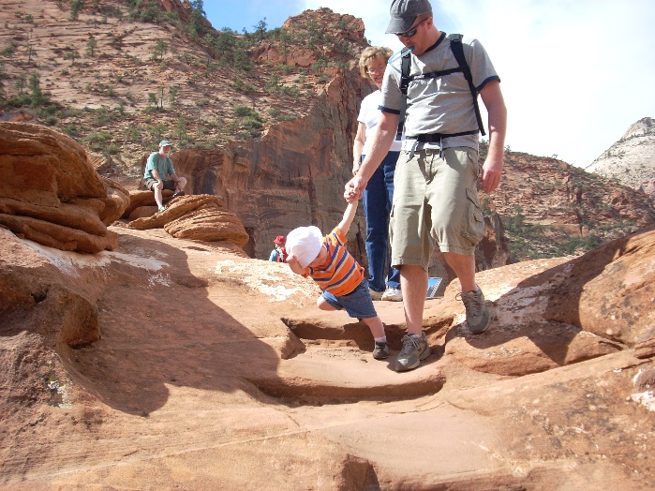didn’t want Ben to walk away when we were not looking. We kept up that tradition of going to Zion’s Canyon during the fall of most years as Rachel was born and we took her in a stroller, and Ben could walk with us. Then Matt was born and he was in the stroller, maybe two were in strollers, I can’t remember. We all had a great time. I think that was when Ben first caught a lizard and from then on, **he loved lizards.** Whenever we went to Zion’s after that, he wanted his dad or someone to help him caught lizards. Today, 2019, he is 13 and he has a large lizard in a glass cage which he got for Christmas 4 or 5 years ago. He really loves lizards, he writes about them at school, he draws them, as well as catches them. He has kept at least three in containers in his bedroom, but finally they all died, except for his big one.

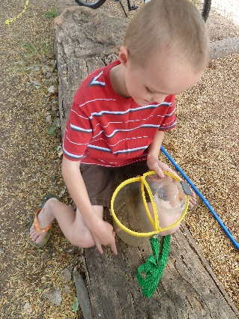Ben also loved to catch insects, when he was younger. He had a net and cute container to put them in. When Ken and I would tend these grandchildren, we would have fun taking them on walks. Ben usually had a pedal car; Rachel had a trike and we pulled Matt in their wagon. We walked around their neighbor in Layton. We also

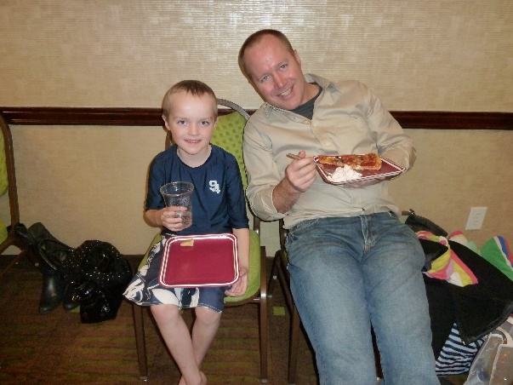Ben plays some sports, but didn’t like them, so didn’t continue. His mom put the kids in swimming lessons for a few years, so they are pretty good swimmers. Their mom also got them in skiing lessons when they moved to Idaho, and they have done that for 2 or 3 years in the winter. Ben grew to love hiking and he and his dad would go climb high peaks in the summers. They have climbed some major peaks in Utah and Wyoming, maybe Idaho, I’m not sure. He also loves climbing and repelling. Ben loves running and he can run a mile in six minutes. He like his dad to go running with him, but Jeff says it is hard trying to keep up with him – he usually can’t unless Ben slows down.

Ben loves to do “Mind Craft” and is good at it. In 2019, Ben also loved typing and they had a Nija typing game where you type and as you type, your car (showing on the computer) is racing other cars. If you win so many times, you get another car (on the computer). Ben loves this and is great at it as he does it several times a day. His highest typing speed is 135. Wow, I was really fast at 120 in my day (when I worked as a secretary.)

When Ben decides to do something, it is hard to get him to change his mind. He started going to bed around 7:30 or 8:00 at night and getting up at 3 or 4 in the mornings as he loved getting up early to do his school homework, doing Mind Craft or typing. He hardly ever let’s anything interfere with this schedule, even when company are staying with them, or we go for treats, play games, etc. He tells us goodnight, gives us a hug and goes to bed and to sleep. Wow! What a guy. He is also pretty much off sugar, except for Sundays. That is great, but I worry about his eating habits as he doesn’t eat much and is very thin.

He and Matt wrestle and have fun together. They also do Mind Craft together. Ben has always been a peace maker. He doesn’t tease or pick a fight with his siblings, rather he tries to get Rachel and Matt to get along better.

**RACHEL LYNN BROWNING**

When Rachel was born, we were happy for Jeff and Gail as now they had a son and a daughter. Ben was excited to have a sister and he loved to hold her and play with her when she got old enough. As she got older, we could see that she was a sweet granddaughter, but she could also throw tantrums. She would scream and throw a fit, if everything didn’t go her way. Jeff called her **“Rachel Bear**” as she was sweet and cuddly, but she could also be a “Bear”. Jeff would have to take her out and sit her in their car in the garage. Of course, he would turn on the garage light, so she wouldn’t be scared, but he didn’t want to hear her loud temper cries. He would leave her there for a few minutes and then go out and talk to her, after she had settled down, and bring her back in the house.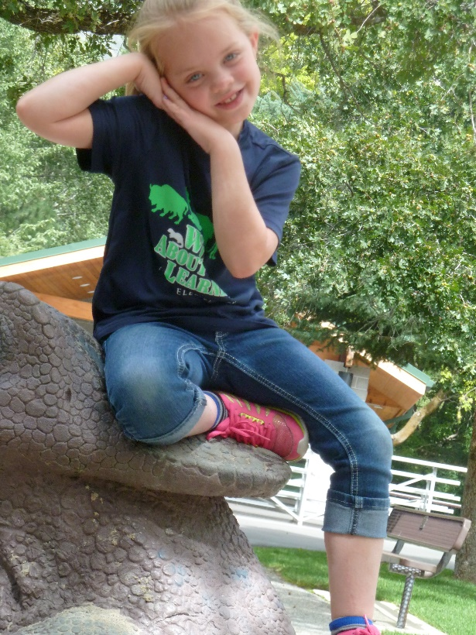

I saw that side of her at times when we were visiting. One time, soon after we had bought our camper, we took it over to show them. We were tending the children while their parents went out on a date. They wanted to sleep in our camper, and their parents said it was okay, if it was okay with us. Ben slept on the top bunk above the table and benches. The table and benches make into a larger bed, so Rachel & Matt slept there. I went out to check on them a couple of times, and Rachel & Matt were fighting. I told them that if they didn’t stop, they would have to come in and sleep in their own beds, so they settled down. The next time I came out, they were again fighting, so I threatened them again that if they didn’t settle down and go to sleep, they would have to sleep in their own beds, and that this was the final warning. The third time I came out, they were fighting again, so I told them to go in the house. Rachel kept begging me to give them another change, but I told her “No” that they had to get out and come into the house. Rachel wouldn’t come, so I grabbed her and was pulling her out, but we kept grabbing onto whatever she could, to stop from being pulled out, well I pulled harder, and we fell out of the camper onto the cement driveway. Rachel fell on top on me, so she wasn’t hurt. I was hurt, so Matt ran into the house to tell Grandpa. Rachel kept saying, “I’m sorry, Grandma, I’m sorry. Ken came out, was worried and helped me into the house. Ben was able to still sleep in the camper, but the other two went straight to their beds. When Jeff and Gail came home soon after, and saw me, they asked what was wrong, and Ken told them. Jeff was upset and went to talk to Rachel. He made her come apologize to me and grounded her from fun things they were going to do the next day and throughout the week (If I remember correctly). I was bruised and sore for a while, but I wasn’t seriously hurt, which was surprising. Rachel is getting much better as she is growing older, but those two still have their problems at times.

Rachel is very creative and loves to make items out of simple materials like cardboard, paper, markers, etc. When they moved from Layton to Kimberly, Idaho, Ken and I go up and usually stay a week. One time while there, Rachel made a cute mailbox, complete with the flag on it. She had the rest of the family write notes to us and she would put them in our mailbox with the flag up. I, in turn, would write some to them and put the flag up. When we were visiting recently (June 2019), she made a cute compartment box with drawers, shelves and holders for her hair brush, curling iron, etc., and had it in the bathroom. She also likes to make jewelry out of beads, etc.

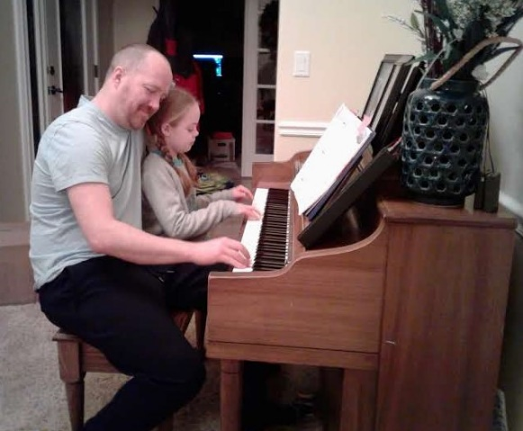Rachel’s brothers love Mind Craft, and she likes it too, just not as much as the boys. She would rather read or watch movies on her kindle. Rachel has been taking piano lessons for a couple of years and is getting good at it. At our family Christmas party program, she and Matt played a piano duet. One time while visiting them, Jeff and Rachel were playing a duet. Rachel likes sports, and played soccer and basketball. She also likes to play volleyball and played with the adults at our family Thanksgiving at our stake center and she did good. Rachel likes to play games with Grandma, especially “Old Pig”.

Rachel sure loves her dad and loves to cuddle with him. I liked this picture of her playing the piano with her dad. We gave this piano, which Ken had bought for me for Christmas one year, soon after we moved into our home. Jeff took lessons, and especially with “cords”, his music is amazing, so we wanted him to have the piano after he was married and the piano wouldn’t fit in our Clinton home.

I have enjoyed tending these children, taking them to Dinosaur Park, Layton Park, McDonalds, etc.

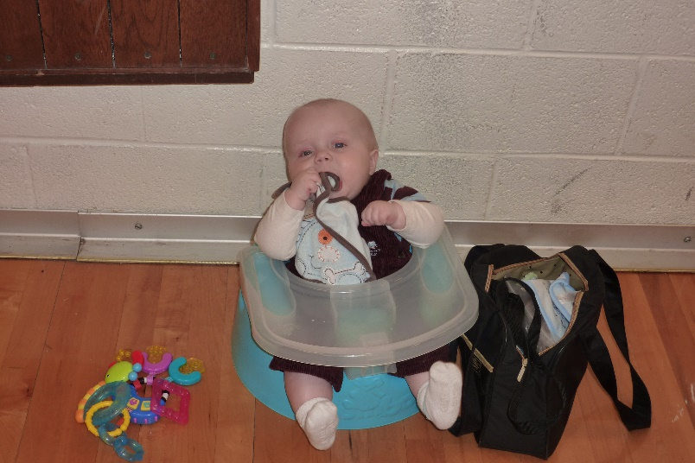**MATHEW LEE “MATT” BROWNING**

**“Matt is our miracle baby** as he saved his dad’s life and brought his parents back together. Jeff and Gail had problems. They had separated, had sold their home in South Weber and Gail & her children had moved into Gail’s widowed mother’s home with her. Jeff was heading out, never to return. (I was heartsick) But Gail found out she was pregnant and told Jeff that she would need his insurance to pay for the delivery and care of this new baby. Jeff knew then that he would have to keep his job, so he asked to be transferred. They had a plant in Ohio, so he was able to transfer there. During these seven months of separation, they realized they really loved each other and they viewed marriage counseling classes on the internet and discussed them when they talked on the phone. They listed the things they would expect of each other and decided they would make their marriage work. We are proud of them as they have a wonderful marriage now.

Matt was such a cute little guy; you couldn’t help but love him. I loved watching him play soccer. His dad coached his team, and Matt and his friends had fun together, but didn’t do too good playing soccer. When he was young, you could always find him sitting on his mom’s lap or his Grandparent’s laps. All of the children went to preschool, and I always went to their graduation programs, and Gail’s mom, Marcy, did also.

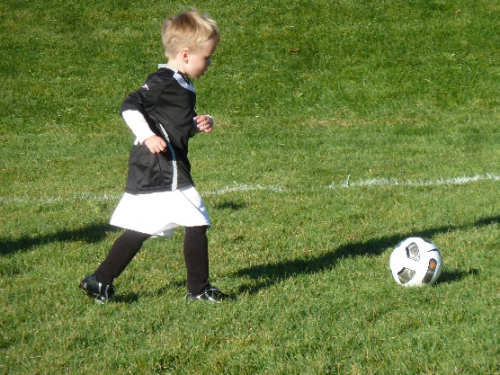Matt has played all the sports when he was young and it was fun watching him play.

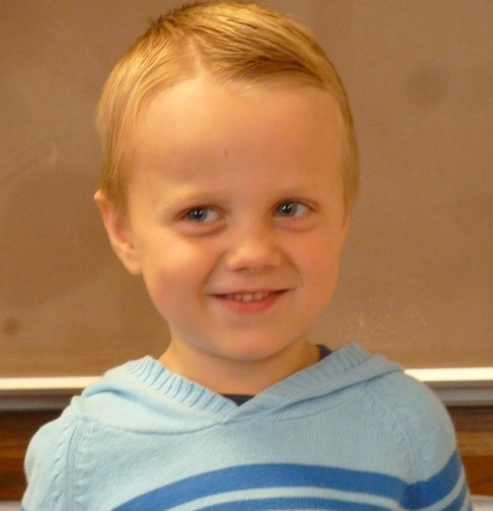Matt turned eight last year and we went to St. George for his baptism as Gail’s family were all going to be there for her nephews farewell before going on his mission (I believe that was the occasion). Jeff doesn’t like that his children get baptized, for which we feel bad, but Gail does. Our other children aren’t that supportive now that four are not active in the church now, and Shellie lives too far away – Arizona, so it didn’t matter to them that she was having it there. Gail had asked Ken to baptize Matt and she asked if I would give one of the talks, which we were honored to do.

Matt is my gameplayer. Whenever we visit, he says “Grandma, can we play a game now”, and we play one game after another. One of his favorites is “Old Pig”. Matt is pretty competitive, and sometime he likes to find ways to block his opponents, rather than concentrating on winning the game. When I get up on the morning, he is right there and wants to play games, and just before Ken and I were leaving, this last time (June 2019), he said: “Grandma, can we play a game before you leave, so Rachel played with us and I played while I ate my cereal before leaving. He’s cute and I do love to play games also, and I enjoy playing them with Matt.

Matt is also taking piano lessons and doing good. This was his preschool picture.

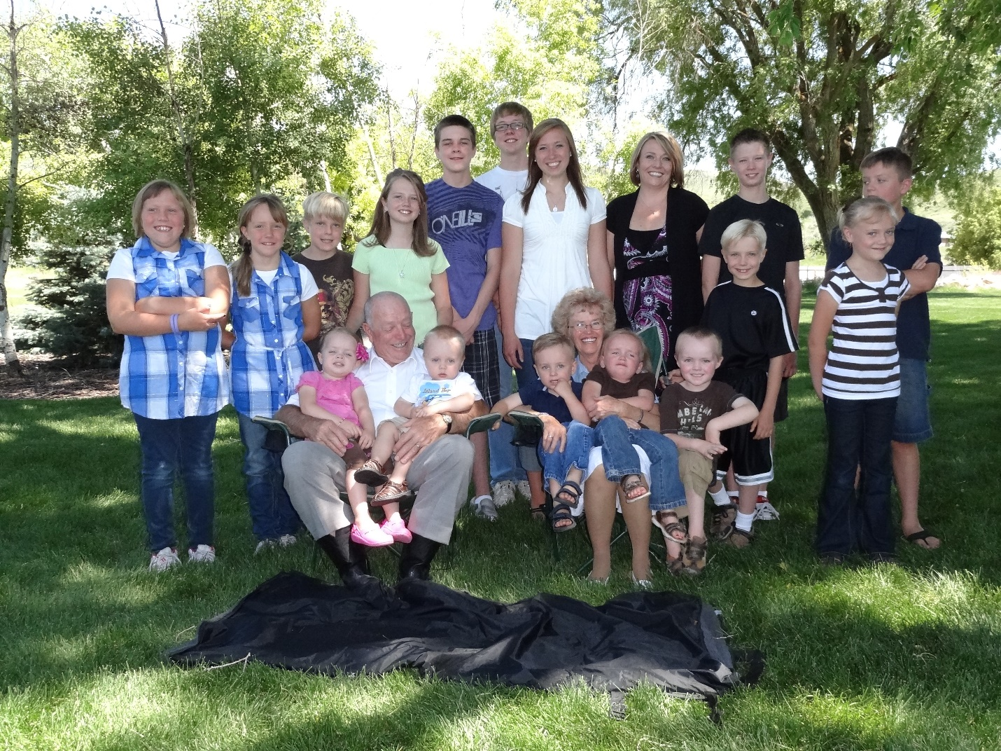

**Our Grandchildren in 2011**

**Back row – Maddy, Jessie, Jase, Emily, Kevis, Quint, Paige, JaNae, Tyler & Kylan**

**Front row – Rachel, Matt, Kaden, Kaitlyn, Ben, Connor & Ashley**

**Chelci, Garrett, & David were missing**